Smart Career Guidance System – API Documentation & System Flow

GROUP -05

- Postman screenshots

AUTHENTICATION SYSTEM
Description | endpoint | method | Postman screenshot
Login and get JWT token | api/users/login | POST | 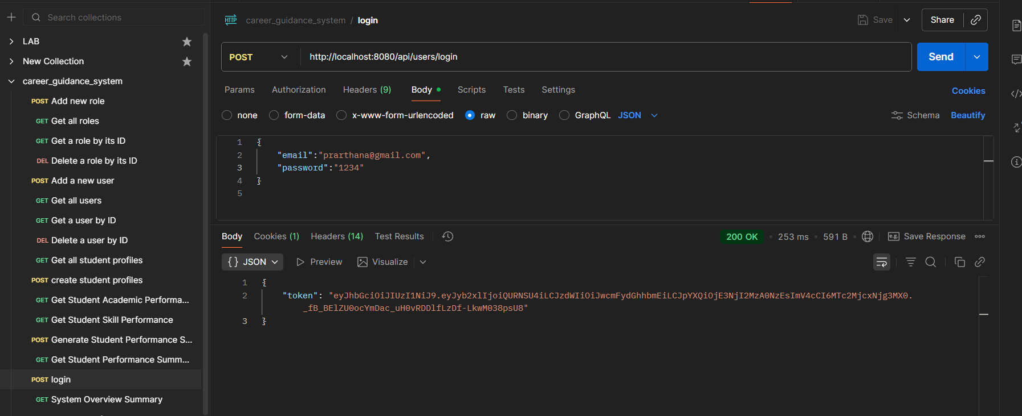

ROLE MANAGEMENT
Description | endpoint | method | Postman screenshot
Add new role | /api/roles/add | POST | 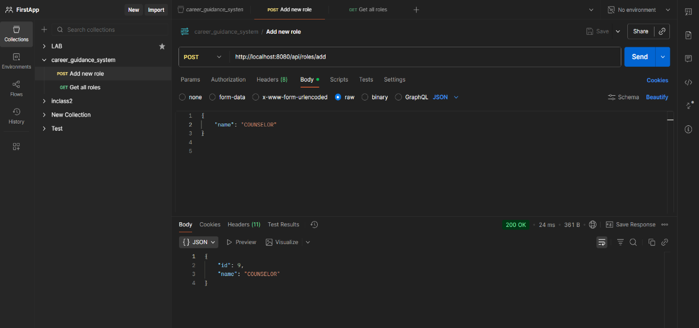
Get all roles | /api/roles/all | GET | 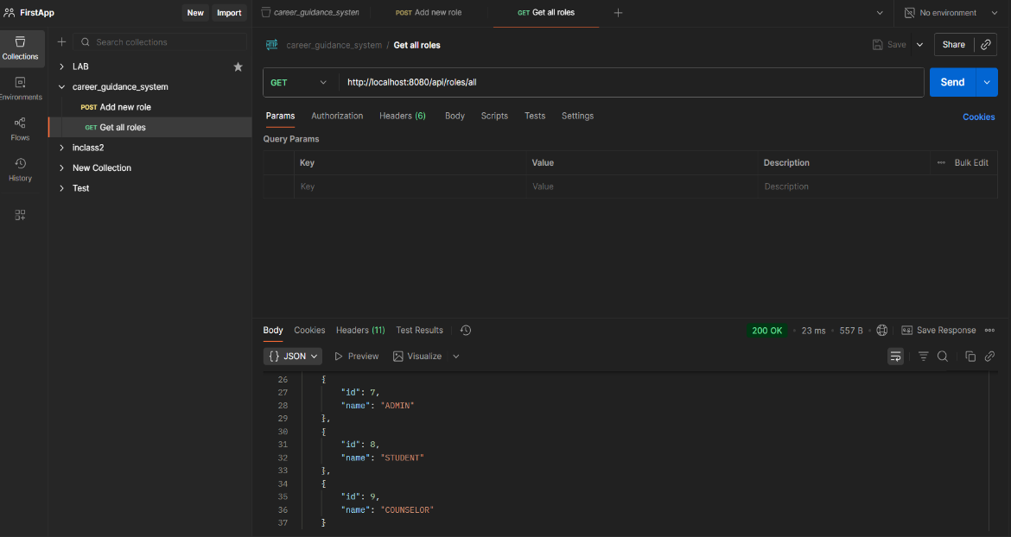
Get a role by ID | /api/roles/{id} | GET | 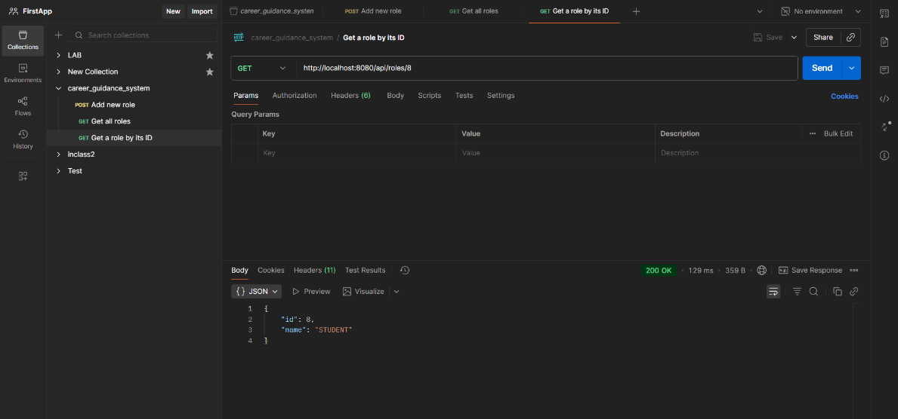
Delete a role by ID | /api/roles/{id} | DELETE | 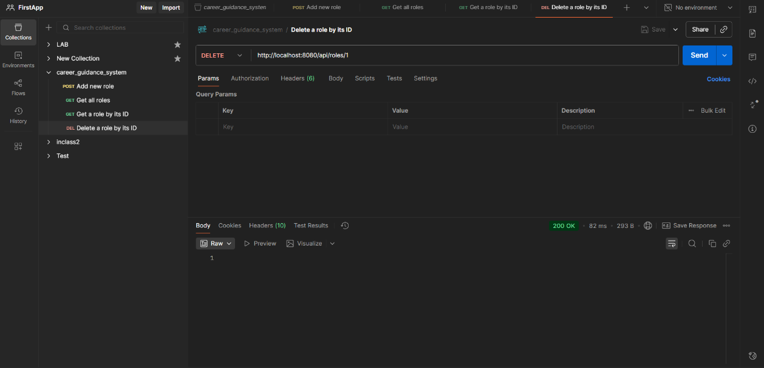

USER MANAGEMENT

Description | endpoint | method | Postman screenshot
Add a new user | /api/users/add | POST | 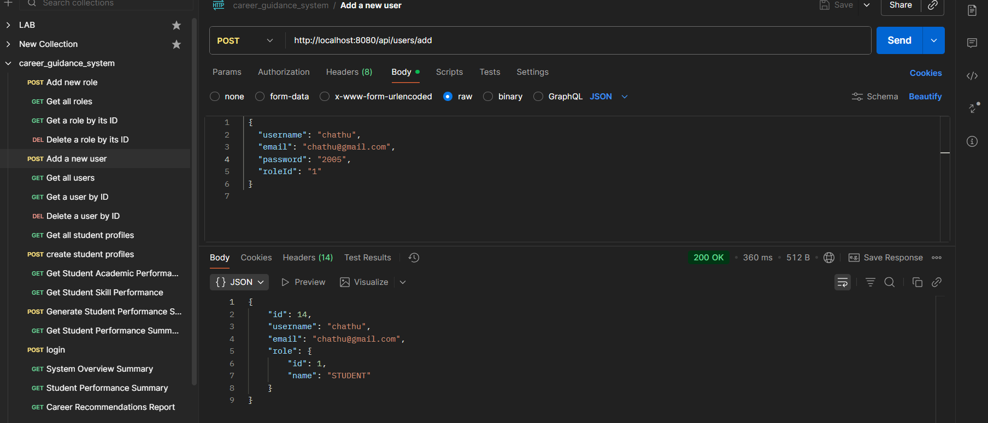
Get all users | /api/users/all | GET | 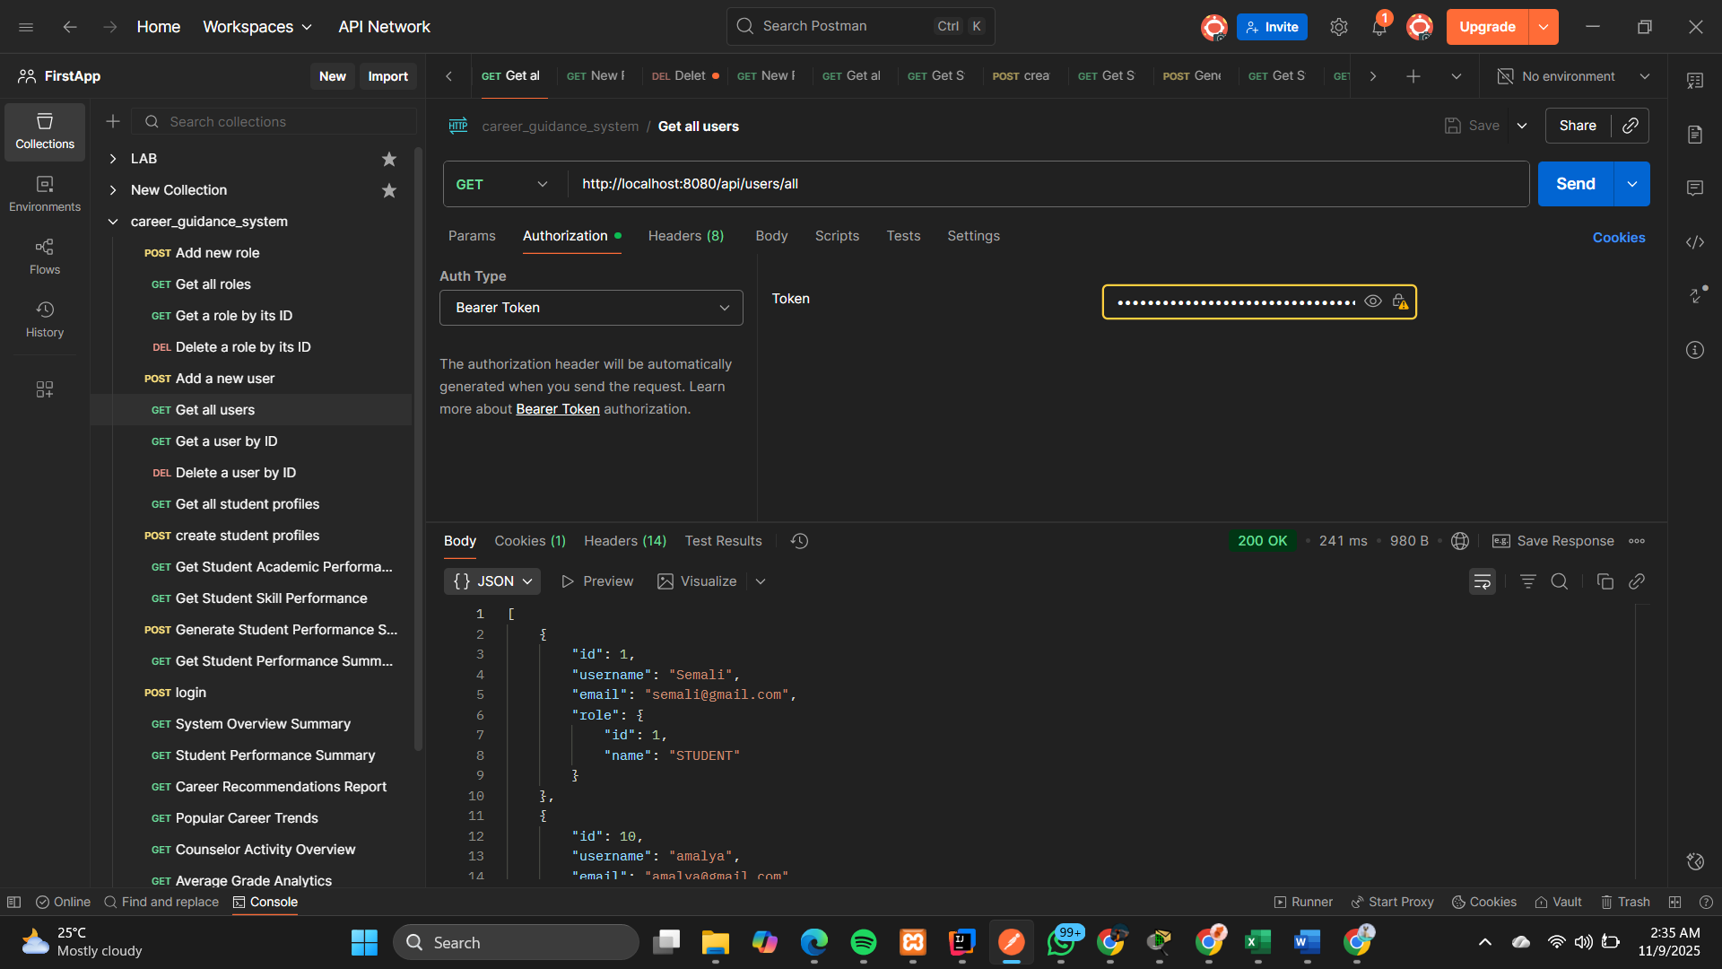
Get a user by ID | /api/users/{id} | GET | 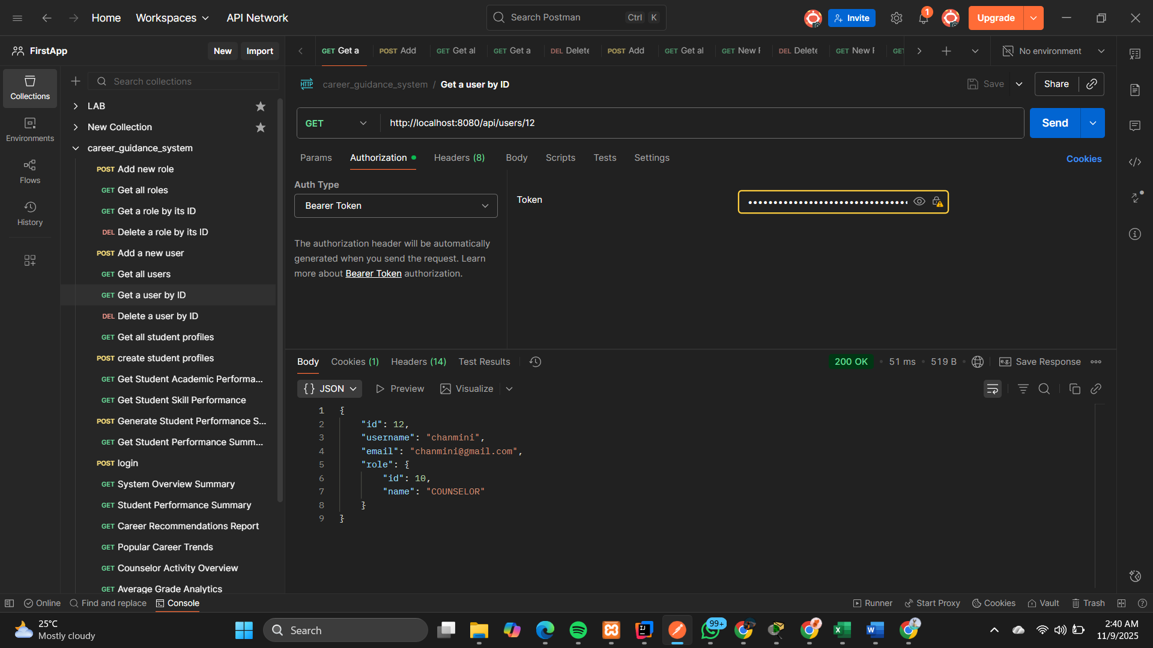
Delete a user by ID | /api/users/{id} | DELETE | 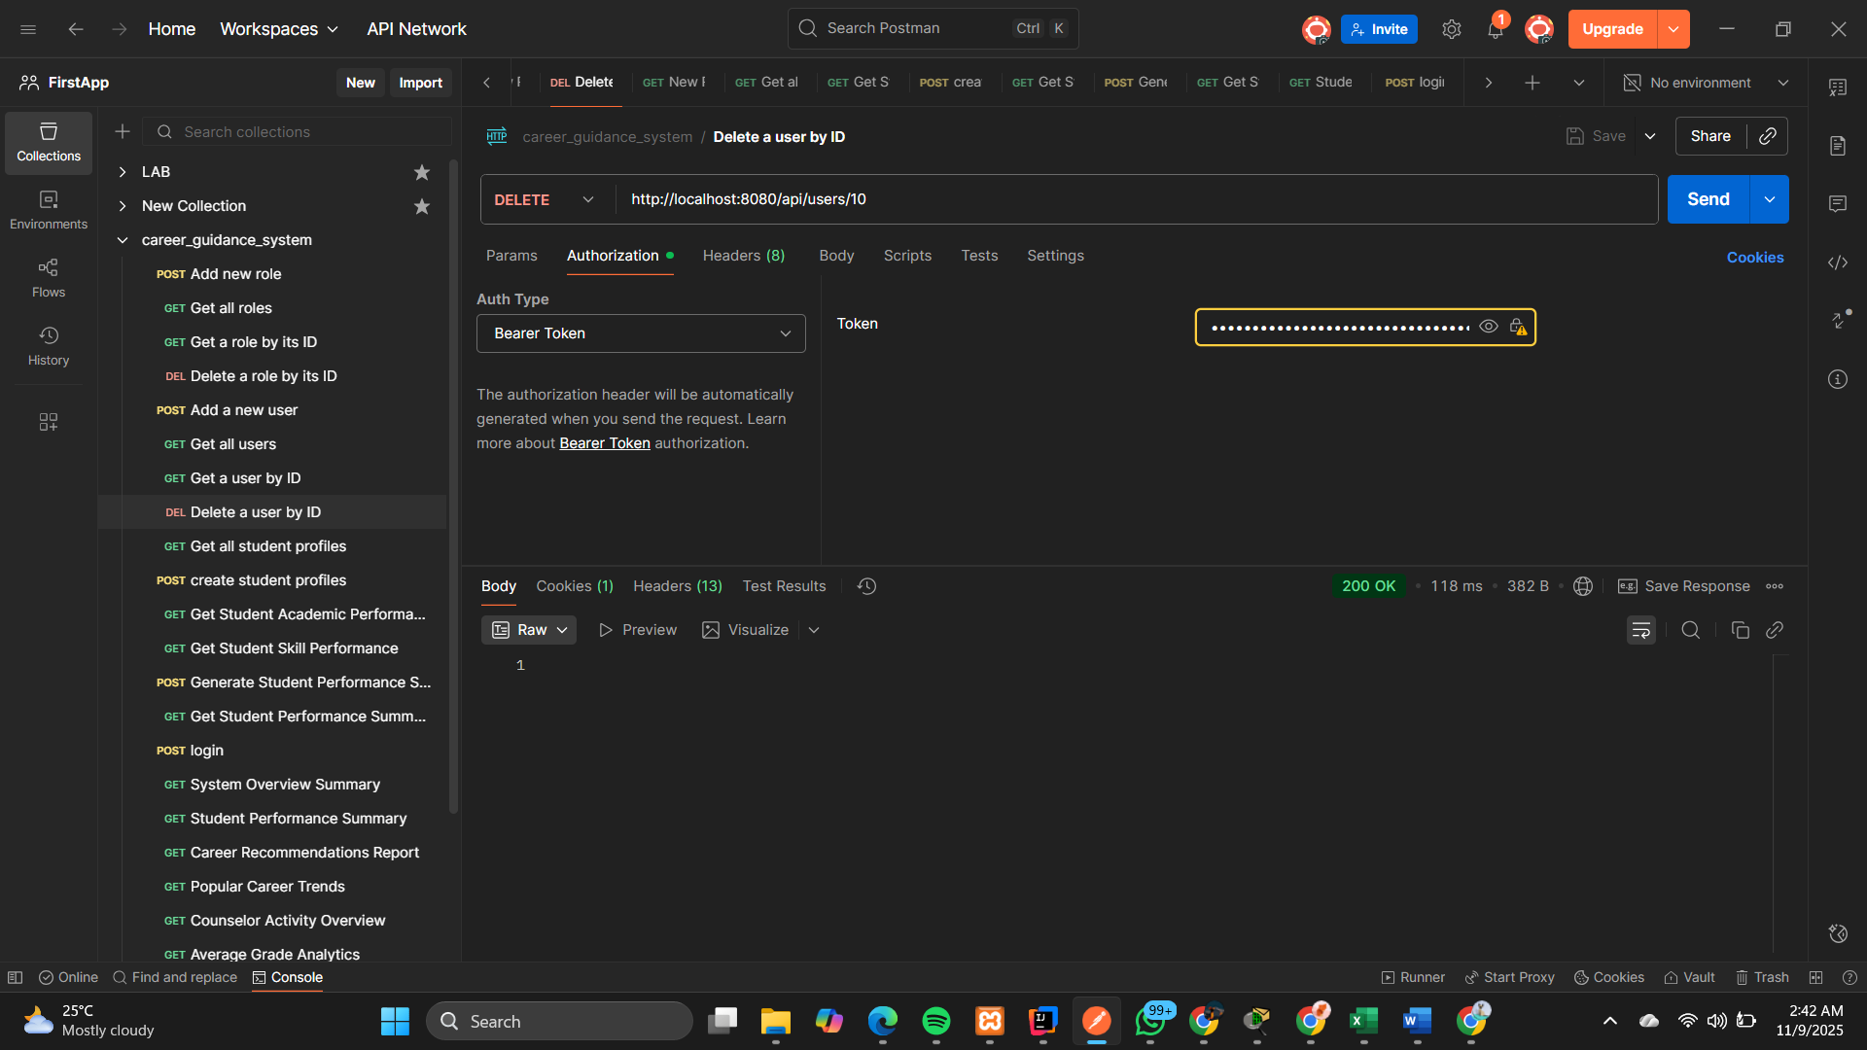

STUDENT PROFILE MANAGEMENT SYSTEM
Description | Endpoints | method | Postman screenshot
Get all student profiles | api/  student-profiles/  all | GET | 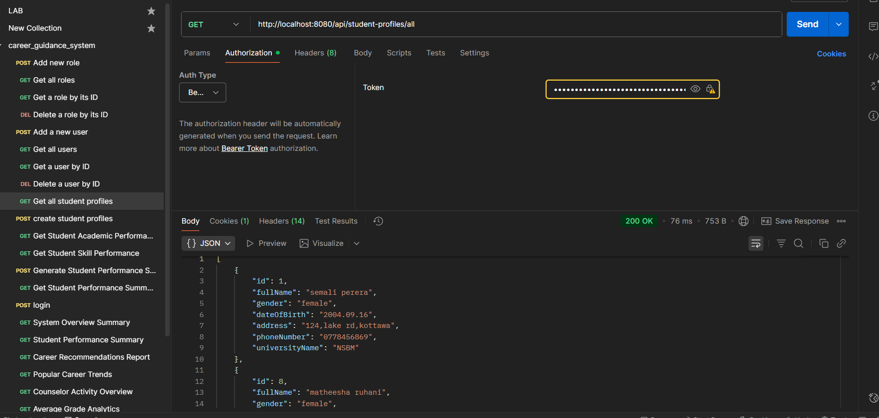
Create student profiles | api/  student-profiles/  add | POST | 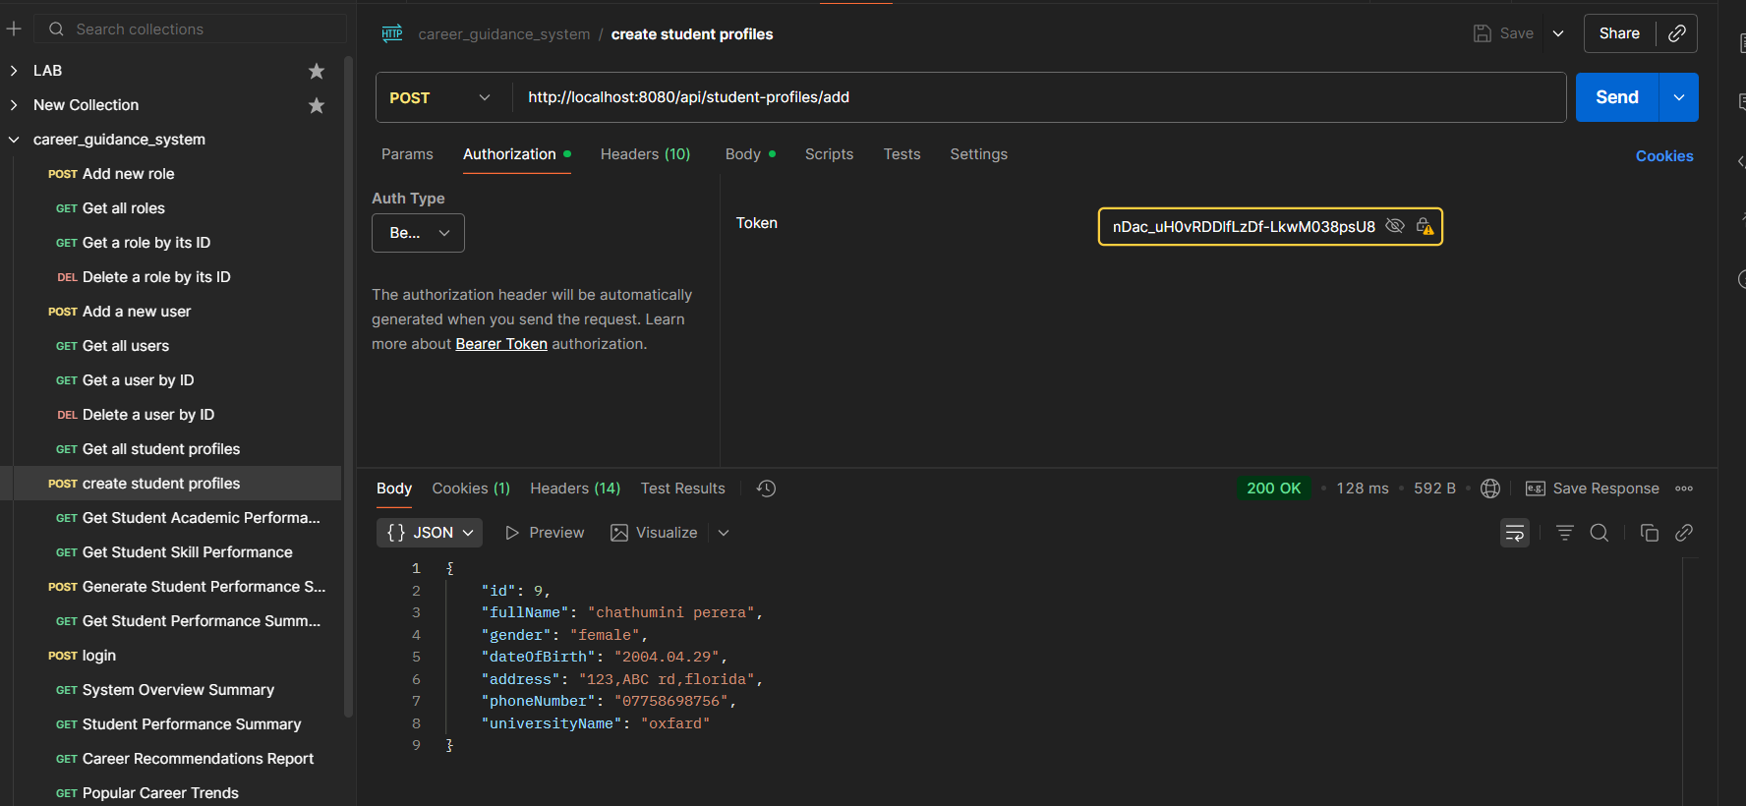
Get student profile by ID | api/  student-profiles/  {id} | GET | 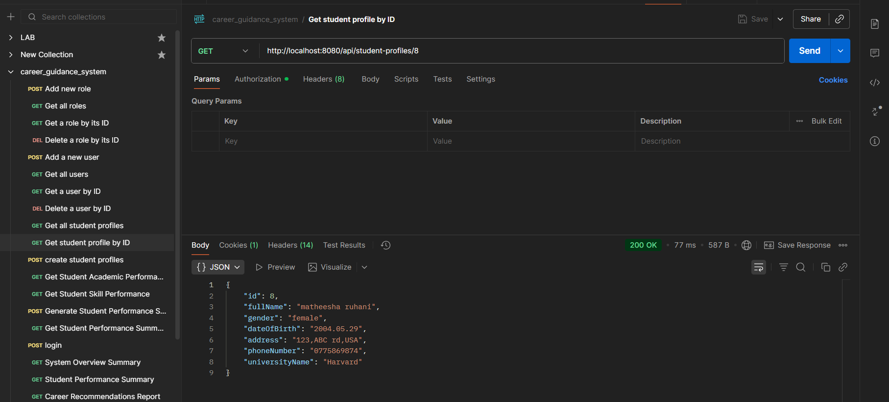
Get student profile by user ID | api/  student-profiles/  users/  {user id} | GET | 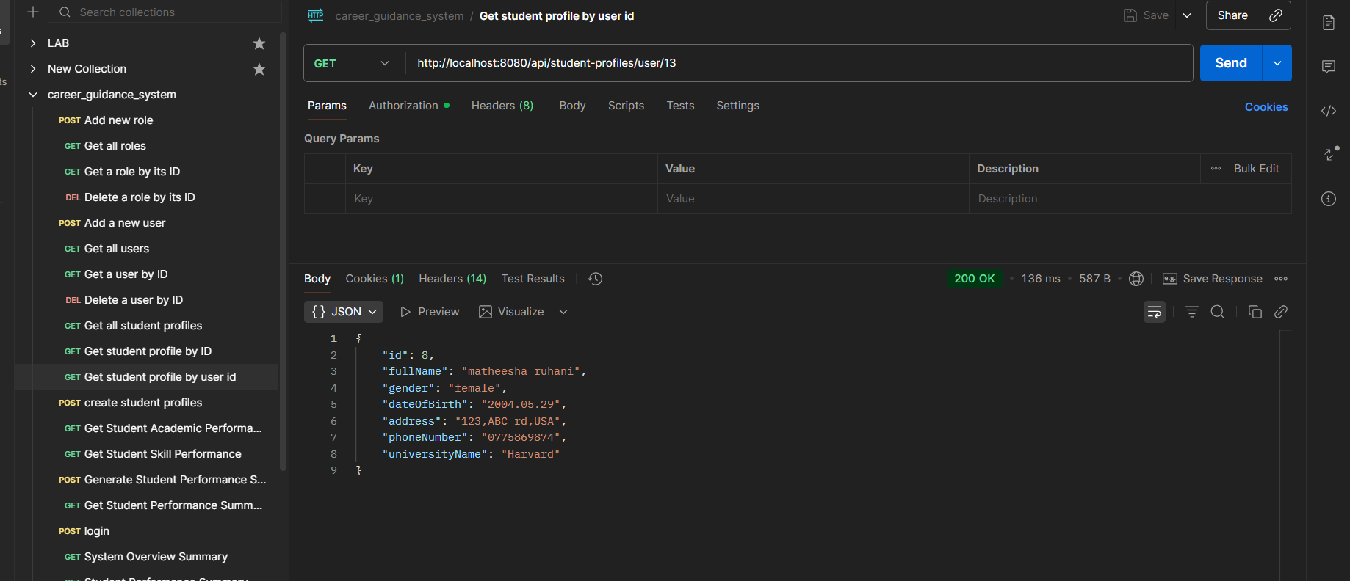
Delete student profile by ID | api/  student-profiles/  {id} | DELETE | 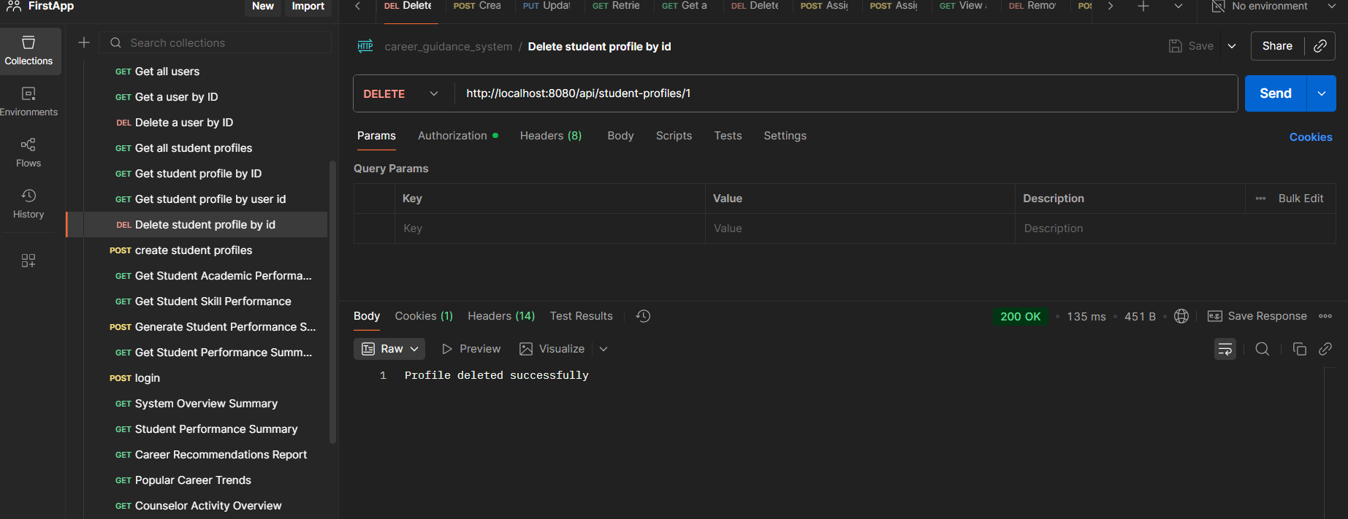

ACADEMIC PERFORMANCE AND SKILL ASSESSMENT

Description | Endpoints | method | Postman screenshots
Get student academic performance | /api/performance  /academic/{id} | GET | 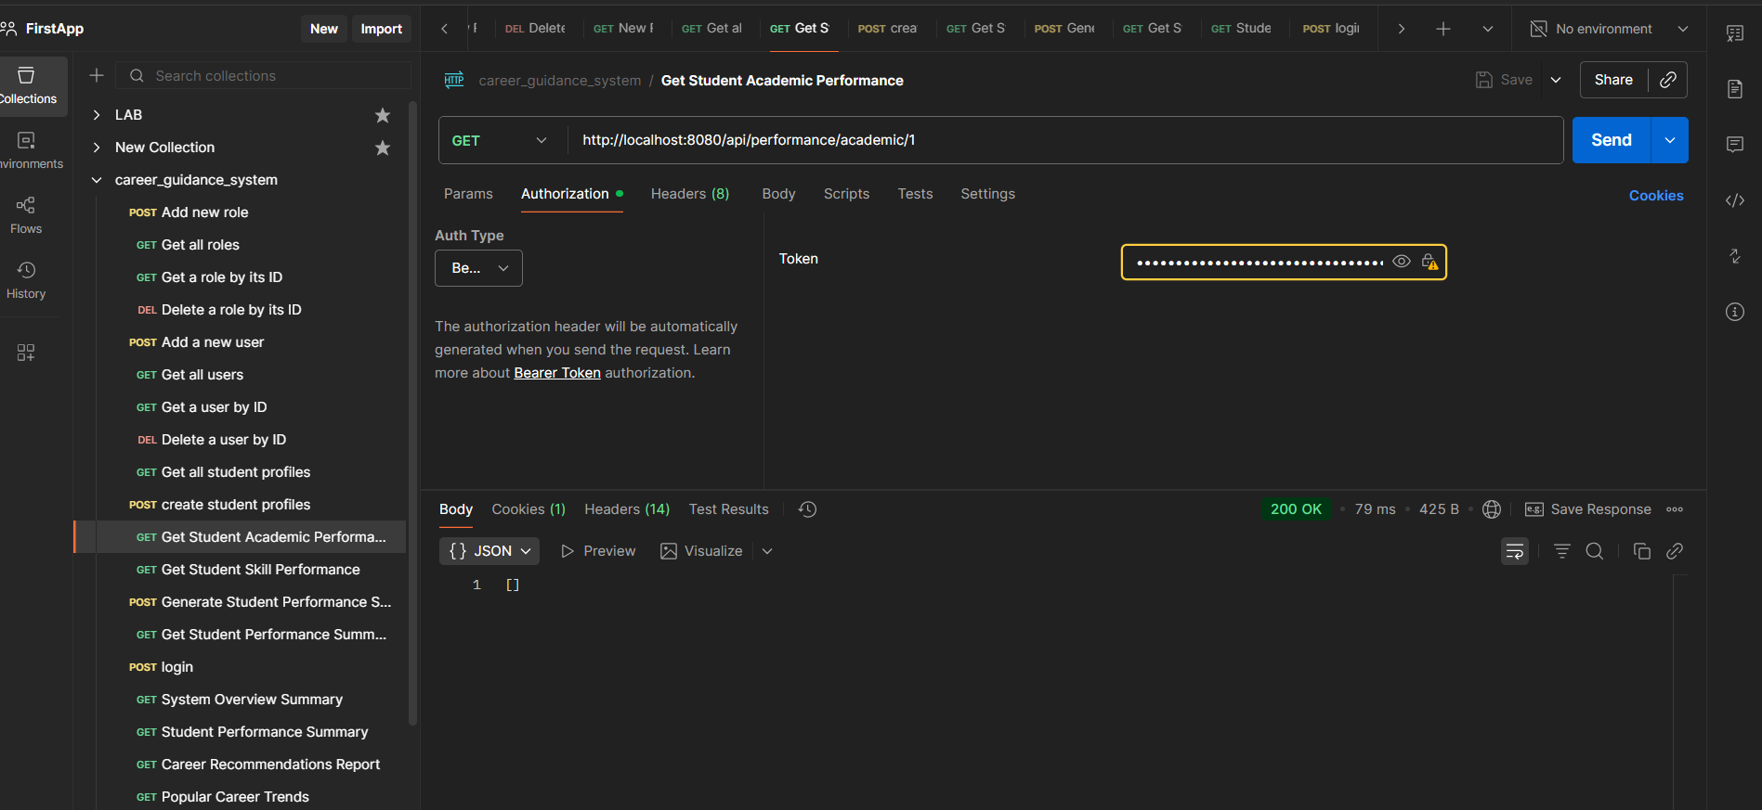
Get student skill performance | /api/performance/  skills/{id} | GET | 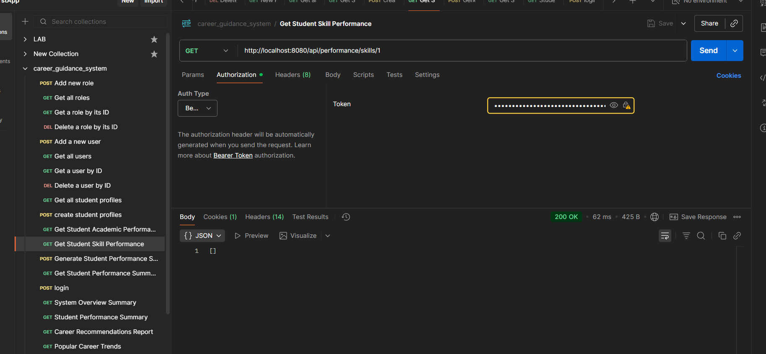
Generate student performance summary | /api/performance/  summary/{id} | POST | 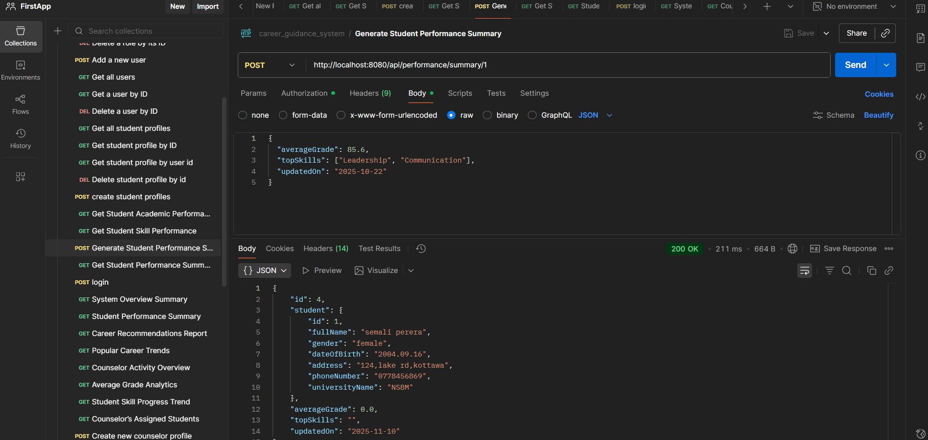
Get student performance summary | /api/performance/  summary/{id} | GET | 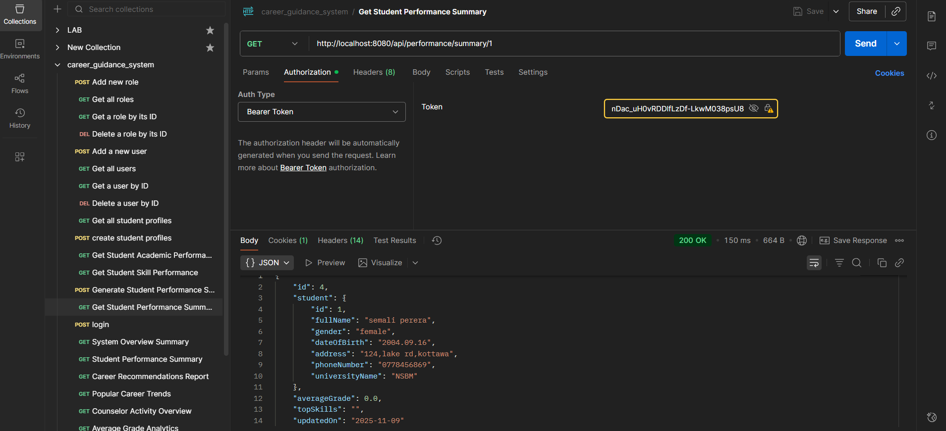

CAREER RECOMMENDATION ENGINE SYSTEM
- Career recommendation
Description | endpoint | method | Postman screenshot
Generate career recommendation | /api/  Recommendations  /generate | POST | 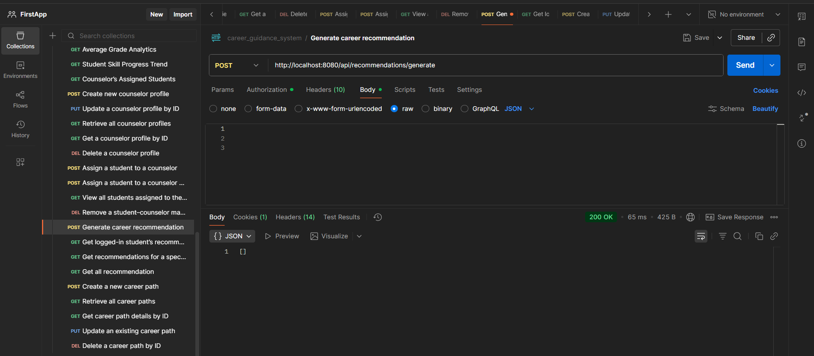
Get logged-in student’s recommendations | /api/  recommendations/  my | GET | 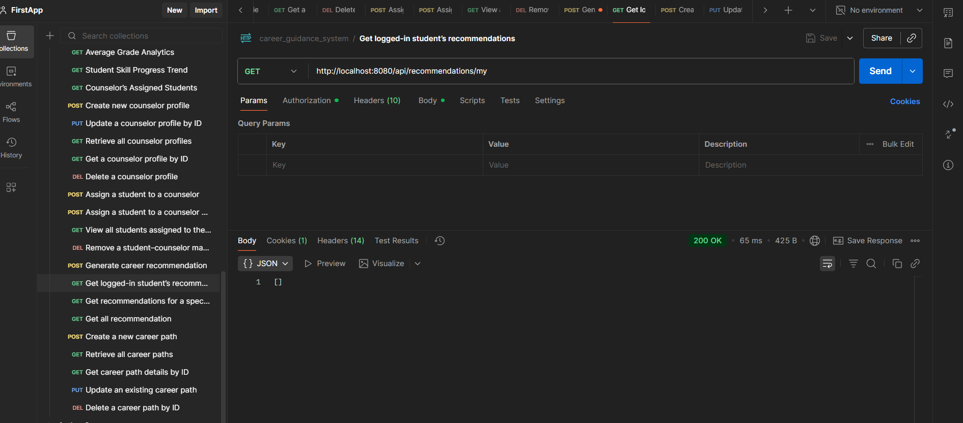
Get recommendations for a specific student. | /api/  recommendations/  student/  {studentId} | GET | 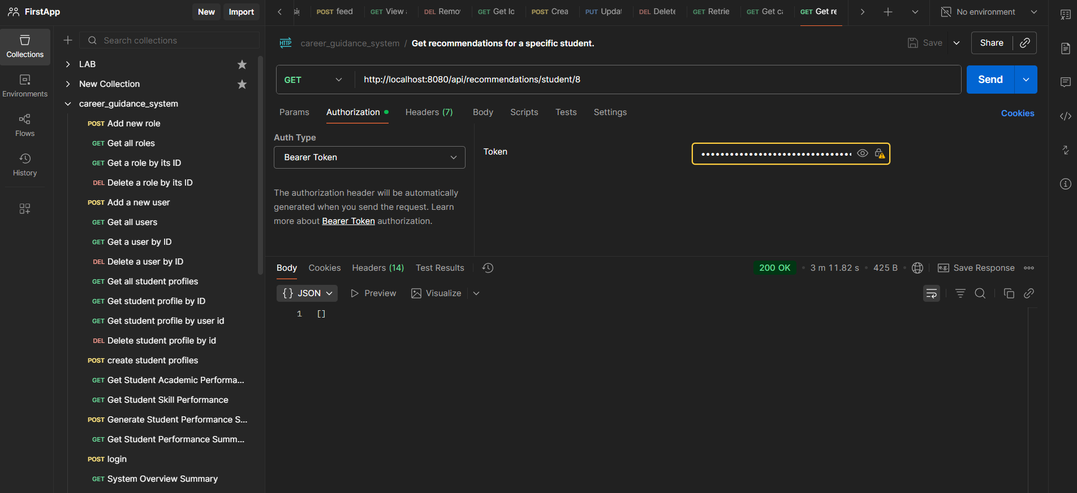
Get all recommendation | /api/  recommendations/  all | GET | 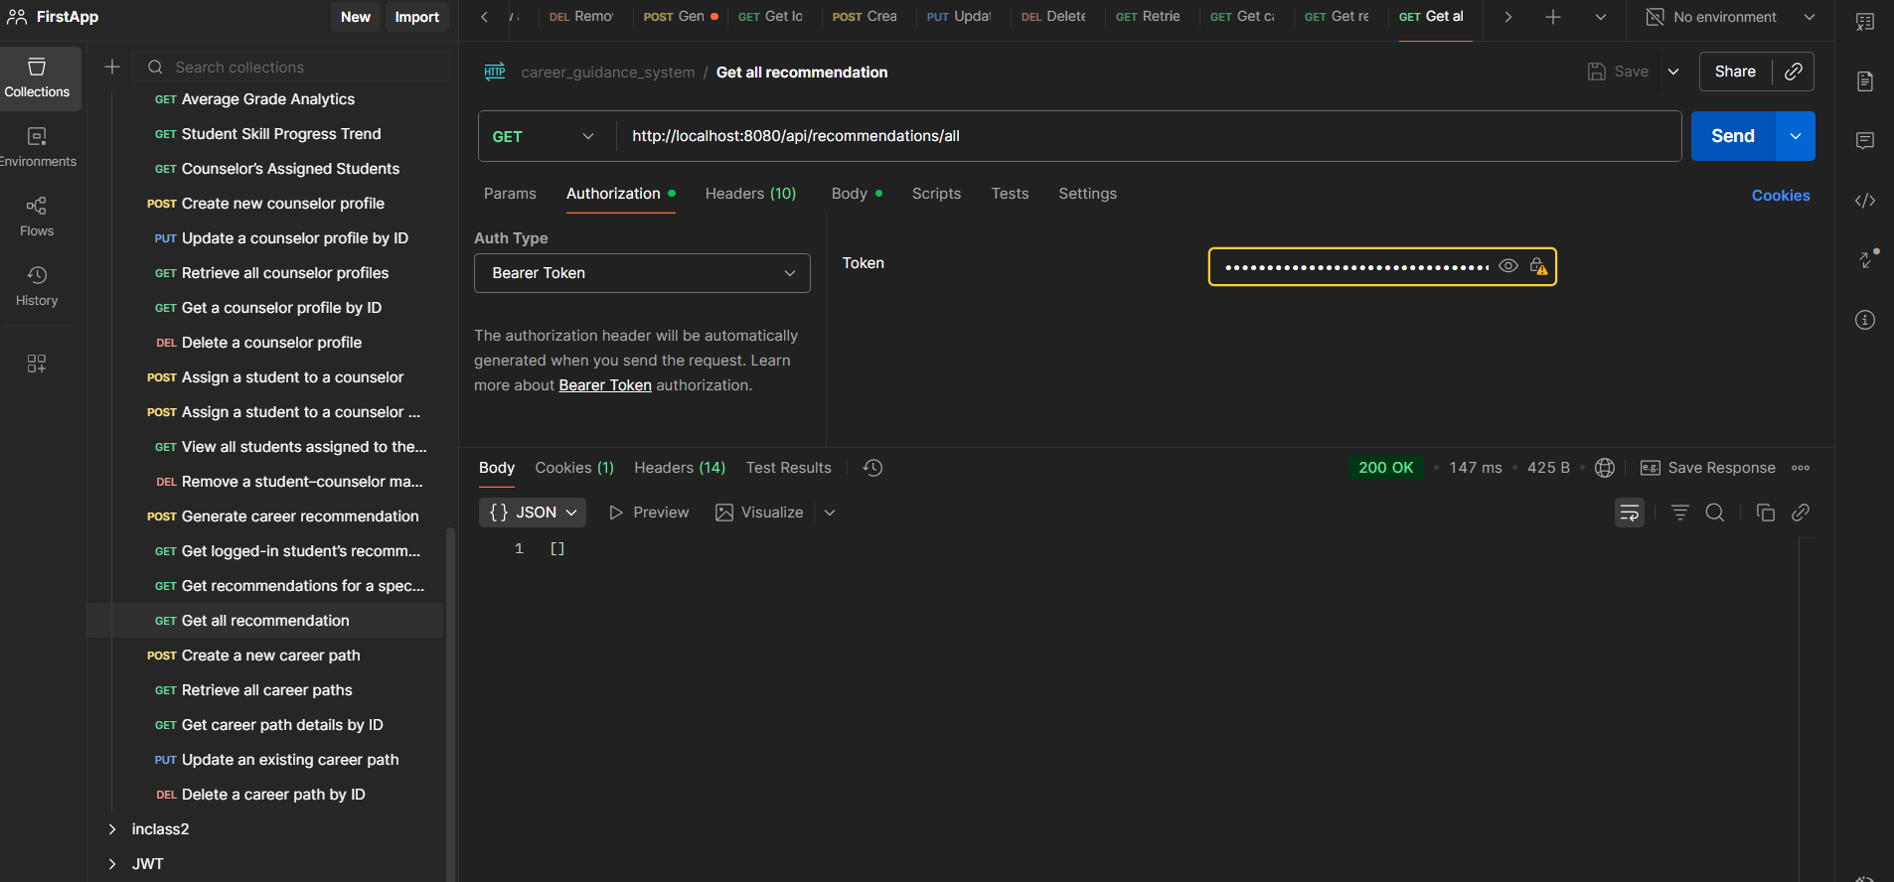

- Career path
Description | endpoint | method | Postman screenshot
Create a new career path | /api/career-paths/add | POST | 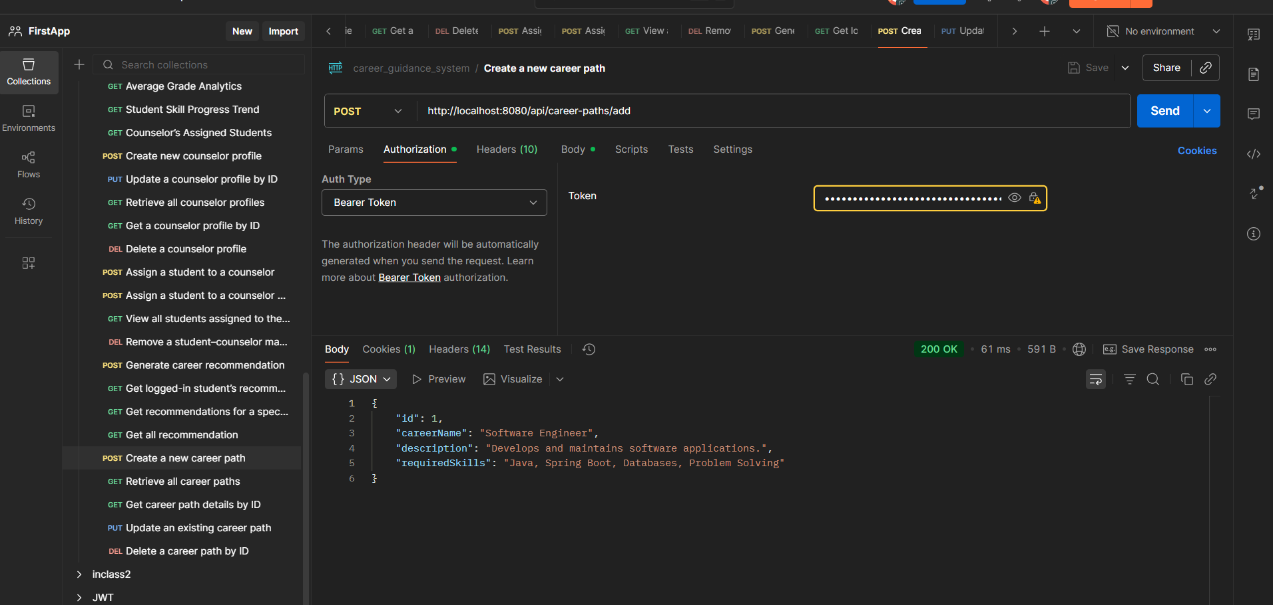
Retrieve all career paths | /api/career-paths/all | GET | 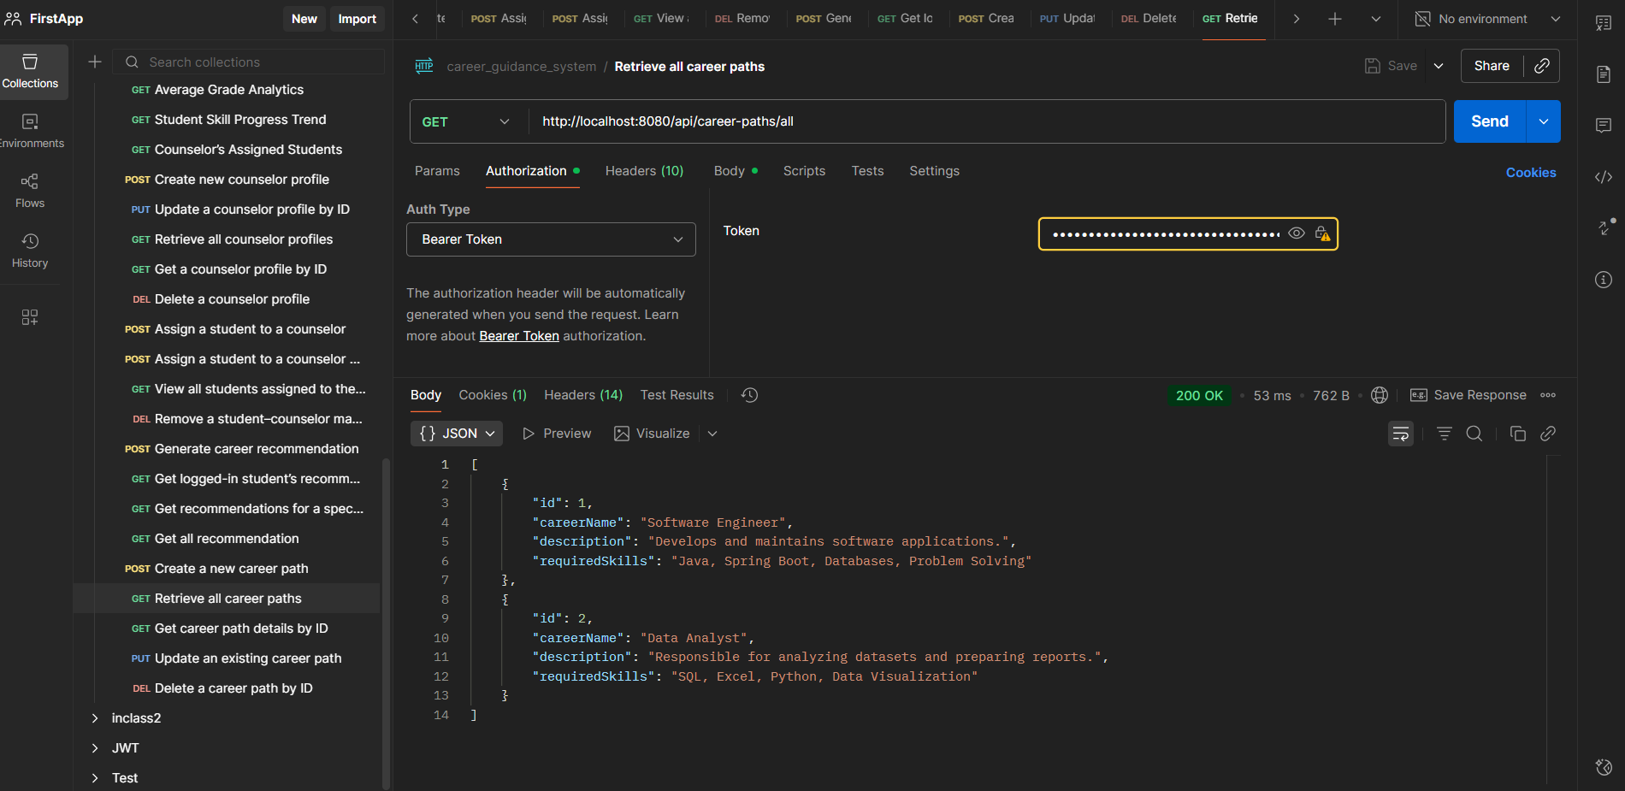
Get career path details by ID | /api/career-paths/{id} | GET | 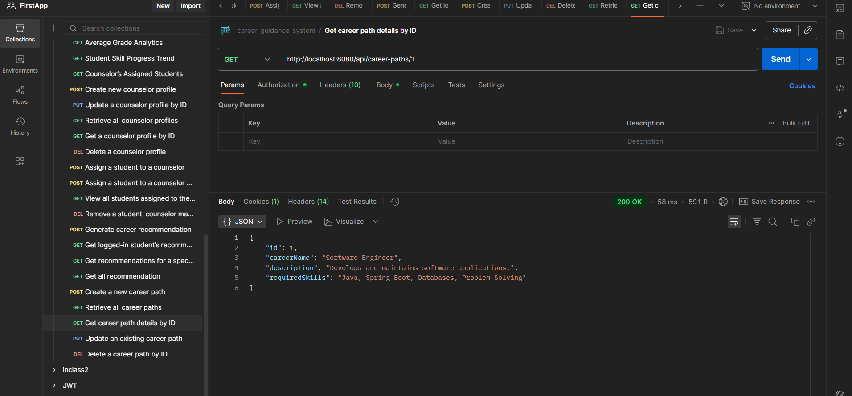
Update an existing career path | /api/career-paths/update/{id} | PUT | 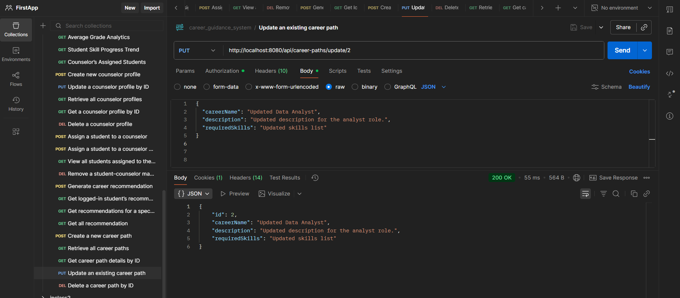
Delete a career path by ID | /api/career-paths/delete/{id} | DELETE | 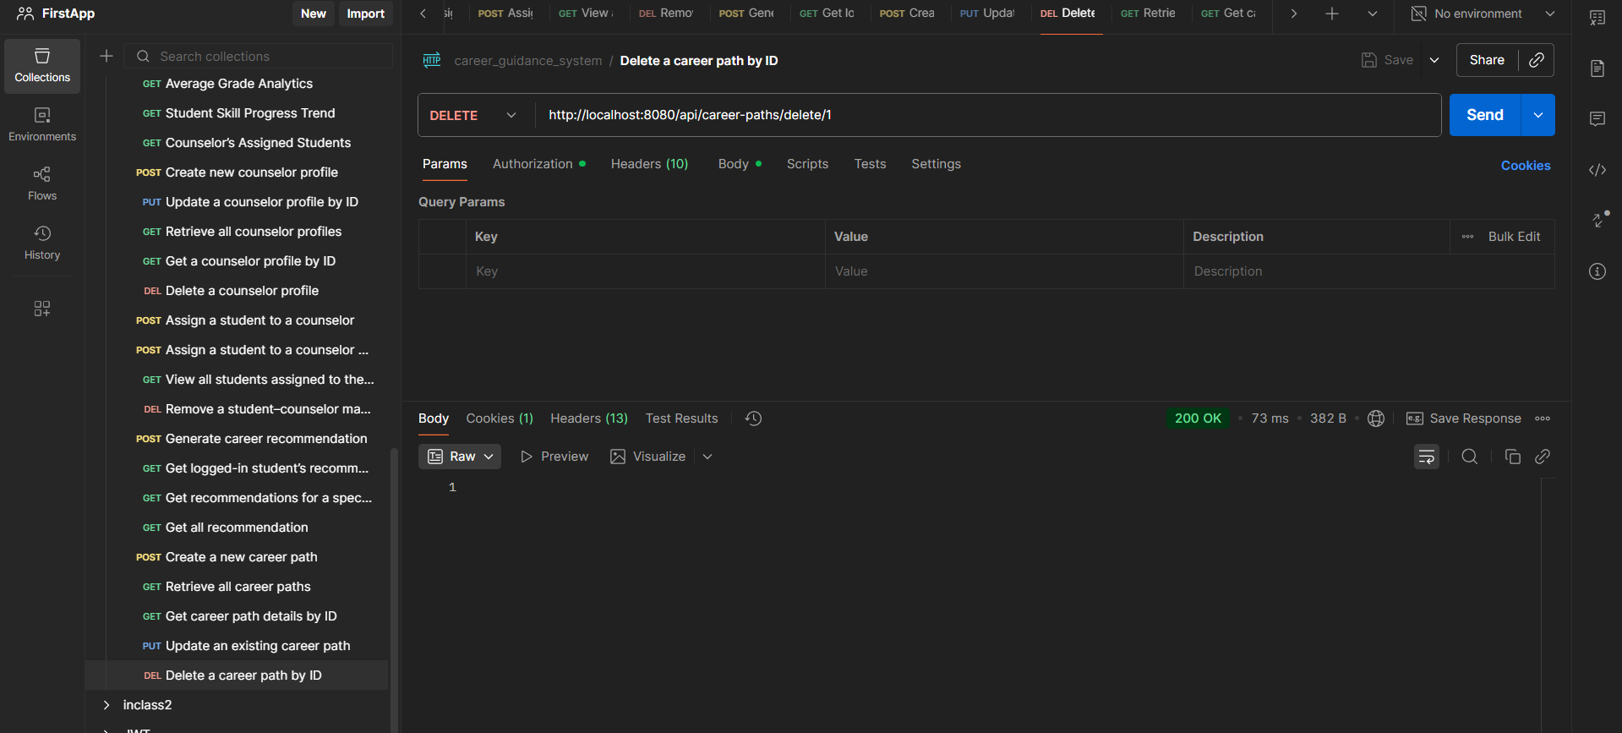

CONSELOR AND ADMIN MANAGEMENT SYSTEM
- Counselor profile endpoints
Description | endpoint | method | Postman screenshot
Create a new counselor profile (Admin only) | /api/counselors/add | POST | 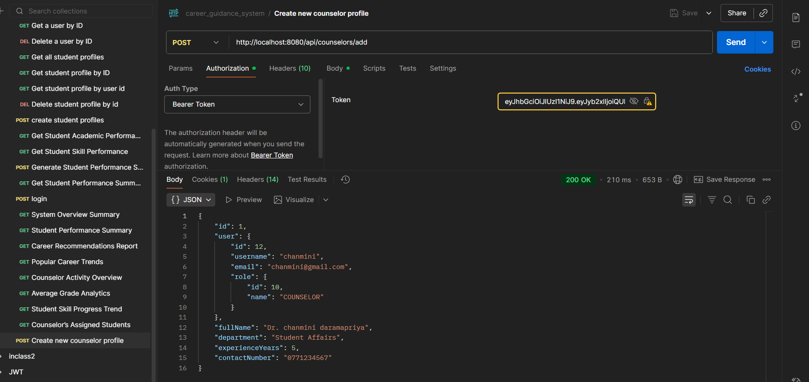
Update a counselor profile by ID (Admin only) | /api/counselors/update/{id} | PUT | 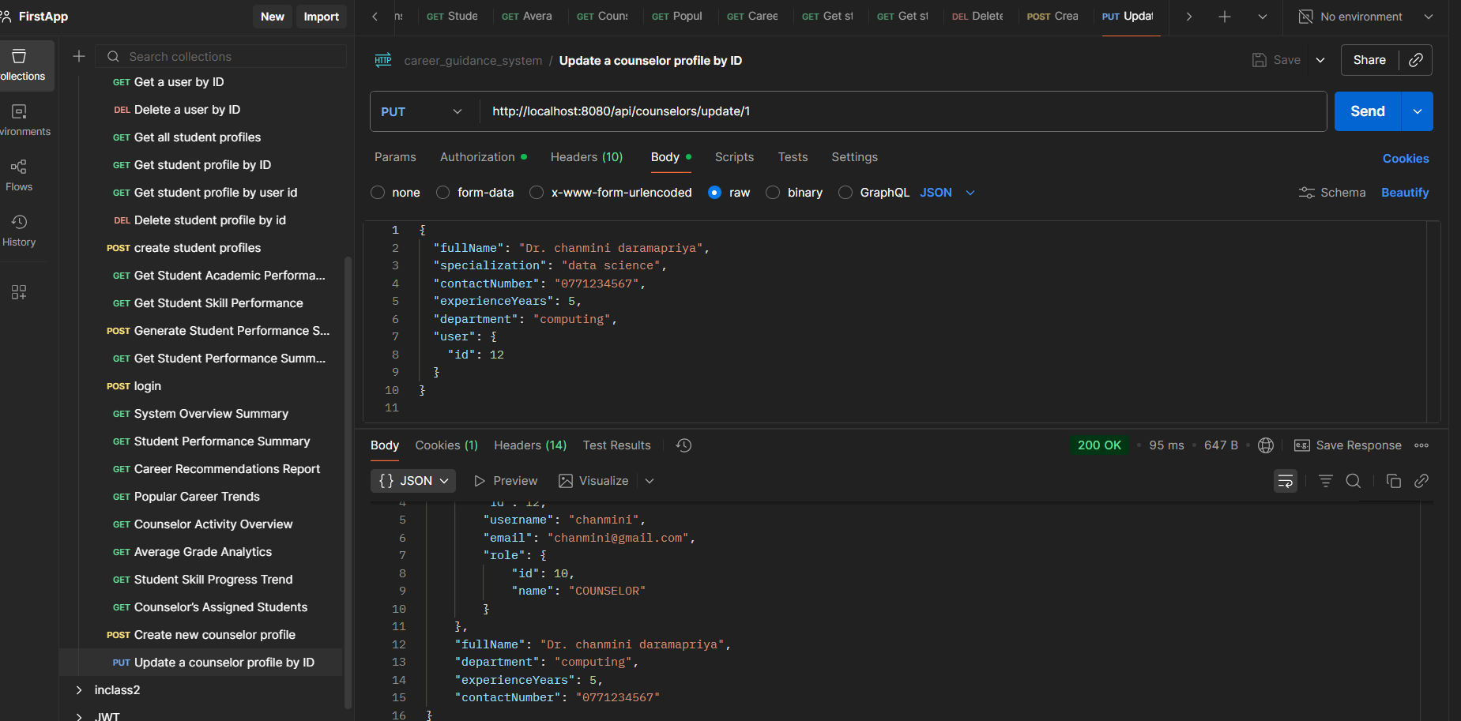
Retrieve all counselor profiles (Admin only) | /api/counselors/all | GET | 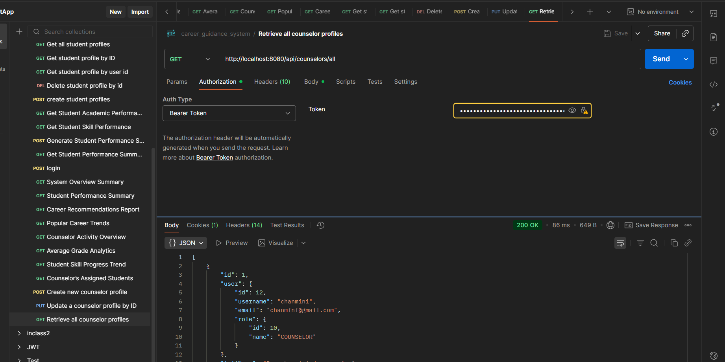
Get a counselor profile by ID (Admin or the counselor). | /api/counselors/{id} | GET | 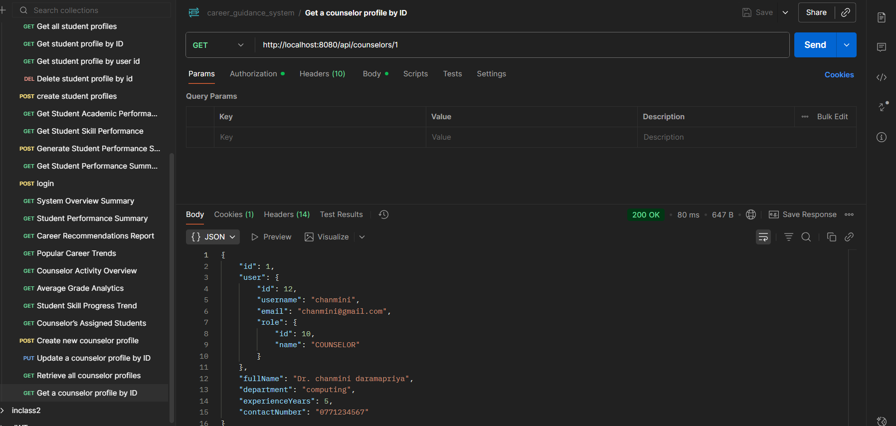
Delete a counselor profile (Admin only). | /api/counselors/{id} | DELETE | 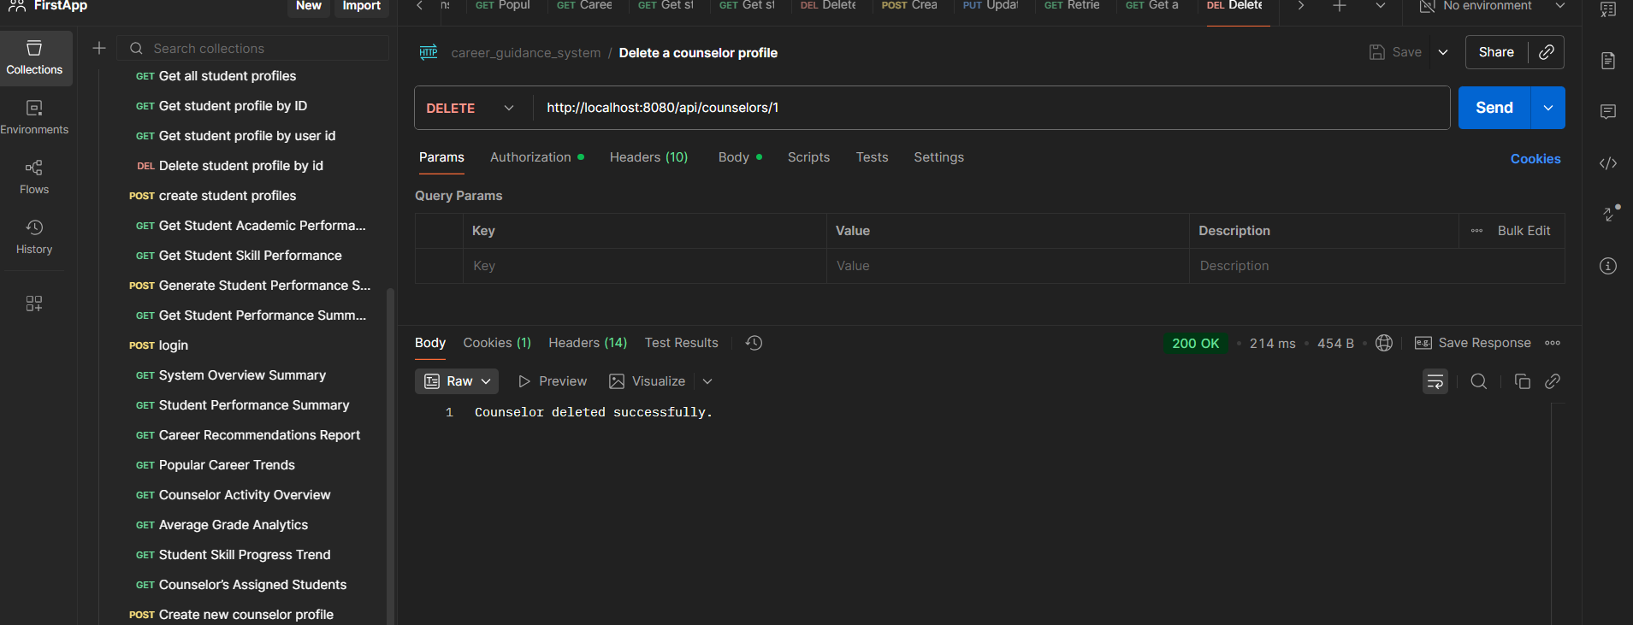

- Student counselor mapping endpoints
description | endpoint | method | Postman screenshot
Assign a student to a counselor | /api  /mappings  /assign/  {studentId}/{counselorProfileId} | POST | 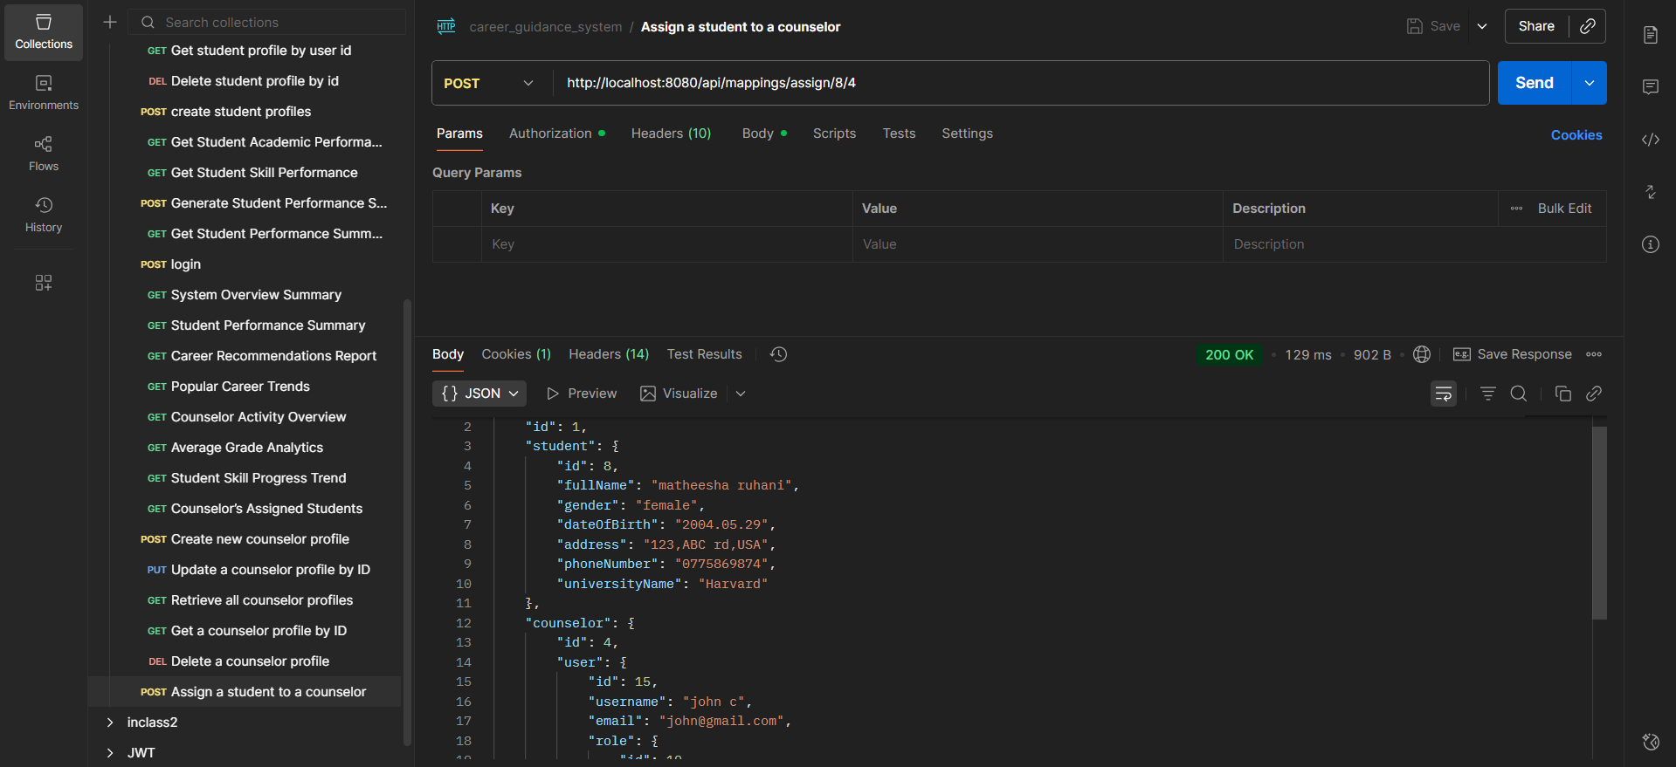
Add counselor feedback for a student | /api/mappings/feedback/{studentId} | POST | 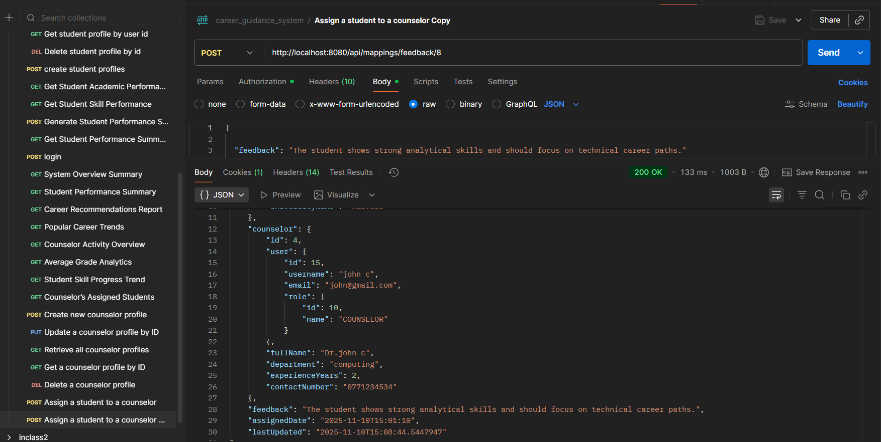
View all students assigned to the logged-in counselor | /api/mappings/my-students | GET | 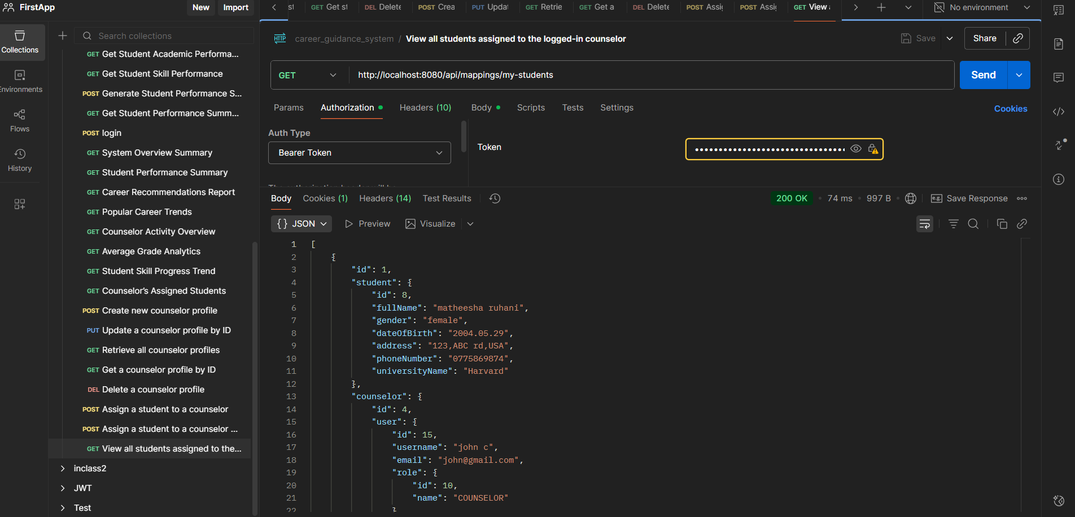
Get all student–counselor mappings | /api/mappings/all | GET | 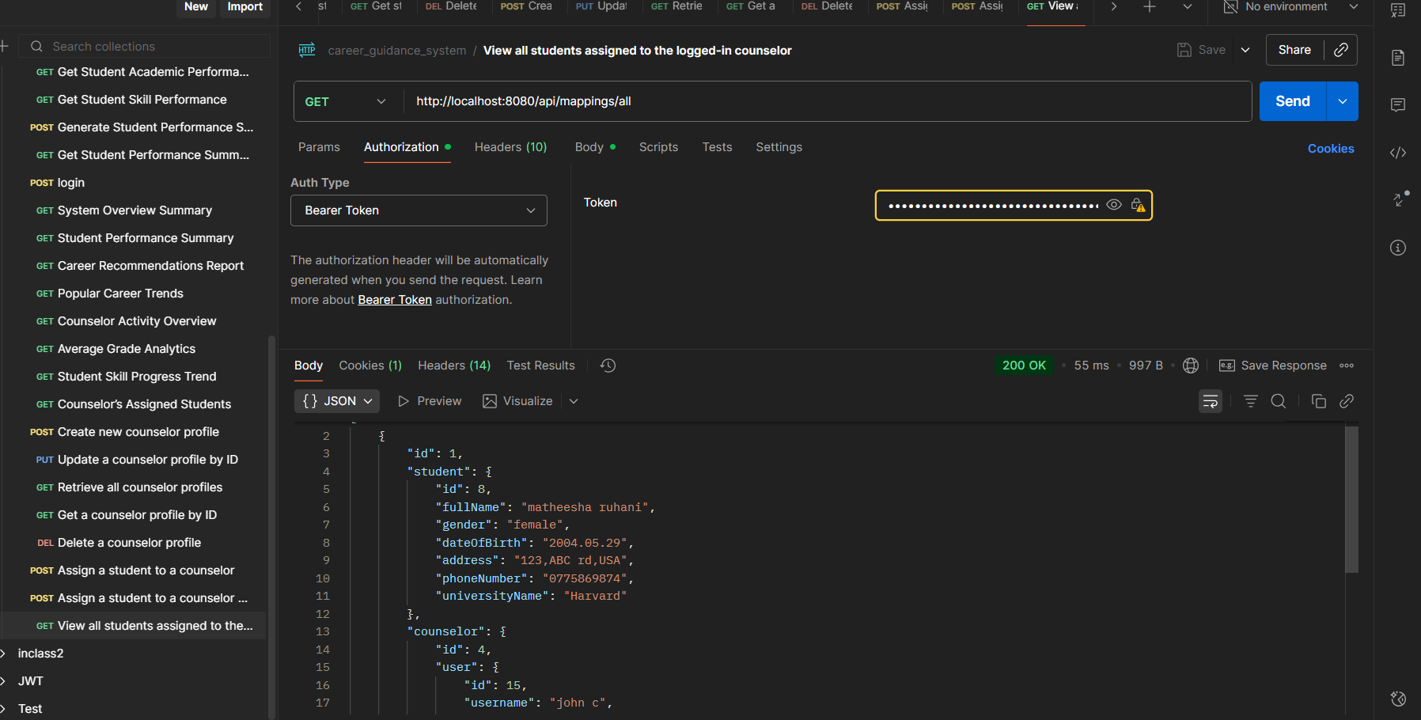
Remove a student–counselor mapping | /api/mappings/remove/{mappingId} | DELETE | 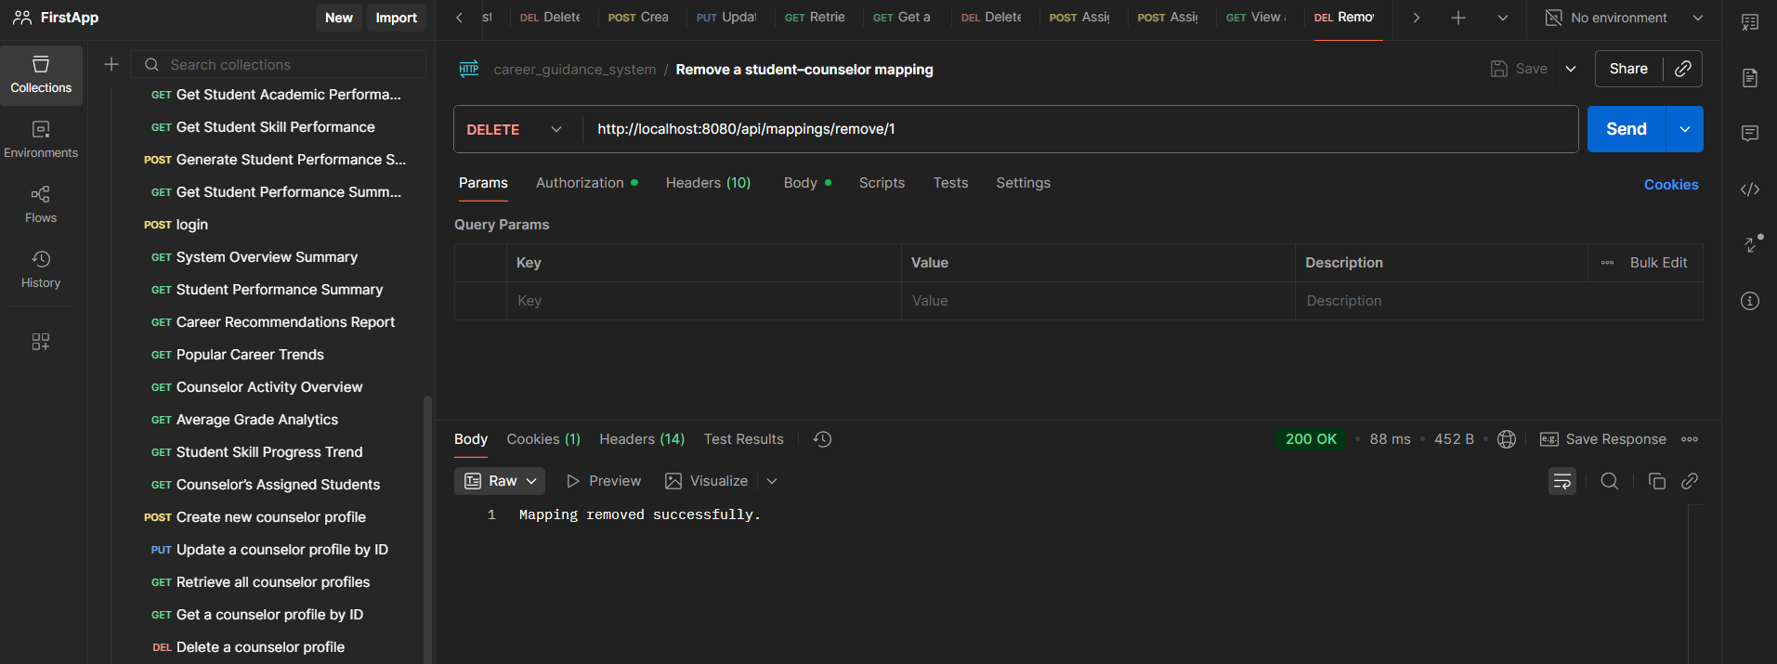

REPORTING AND ANALYTICS SYSTEM
Description | endpoint | method | Postman screenshot
System Overview Summary | /api/reports/  overview | GET | 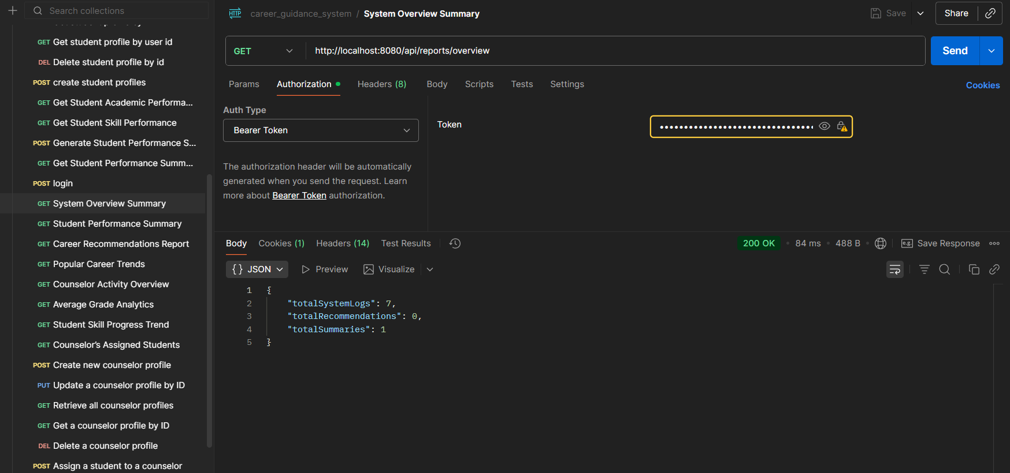
Student Performance Summary | /api/reports/  student  /{studentId}/  performance | GET | 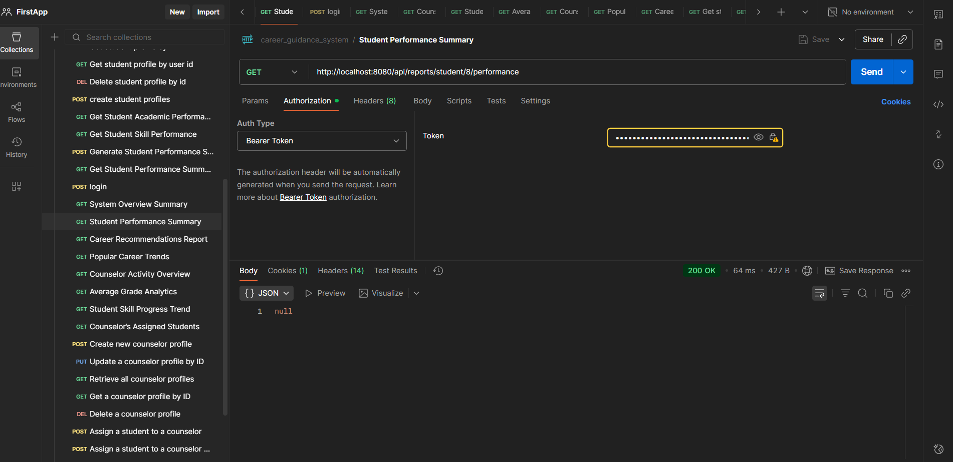
Career Recommendations Report | /api/reports/  student  /{studentId}/  recommendations | GET | 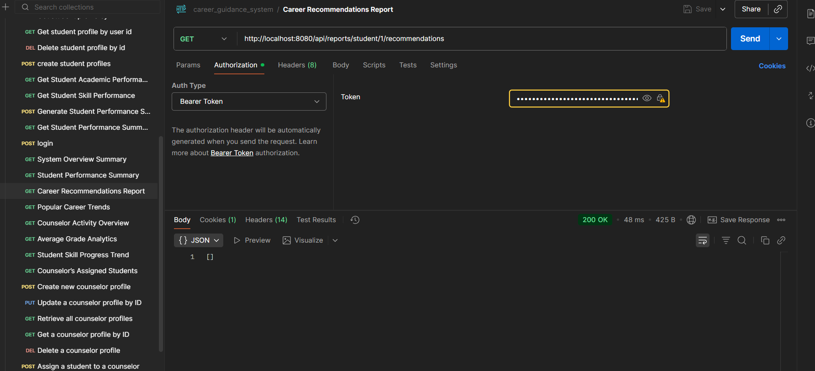
Popular Career Trends | /api/reports/  popular-careers | GET | 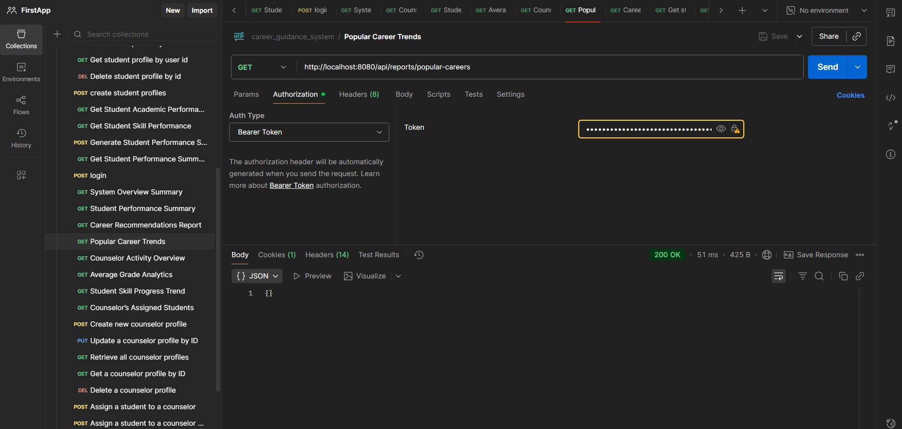
Counselor Activity Overview | /api/reports/  counselor-activity | GET | 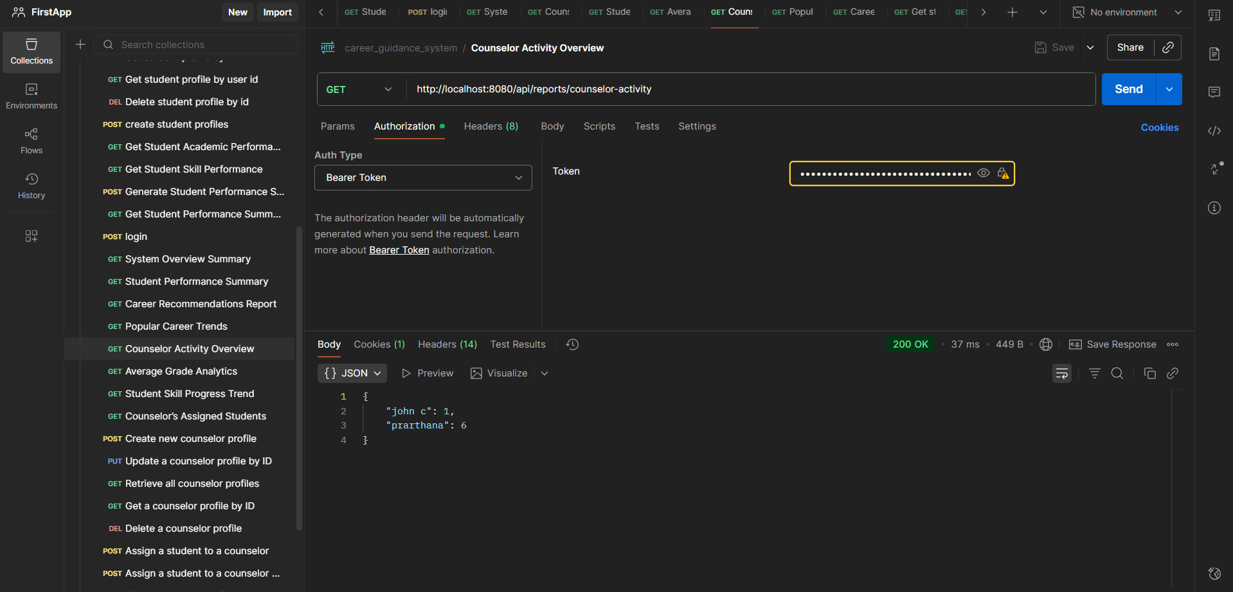
Average Grade Analytics | /api/reports/  average-grade | GET | 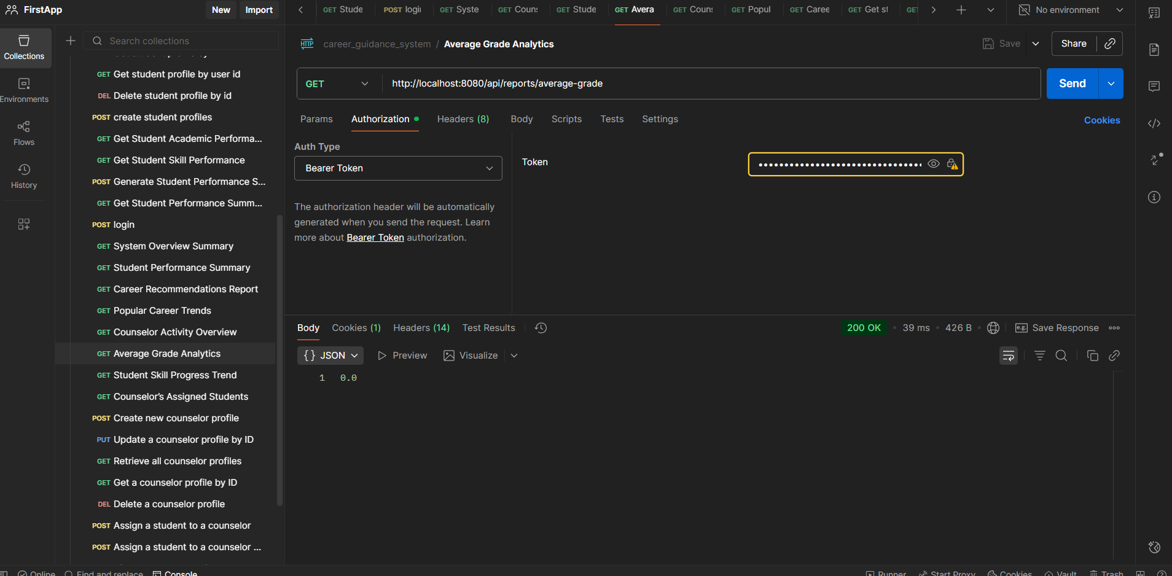
Student Skill Progress Trend | /api/reports/  student/{studentId}/  skill-progress | GET | 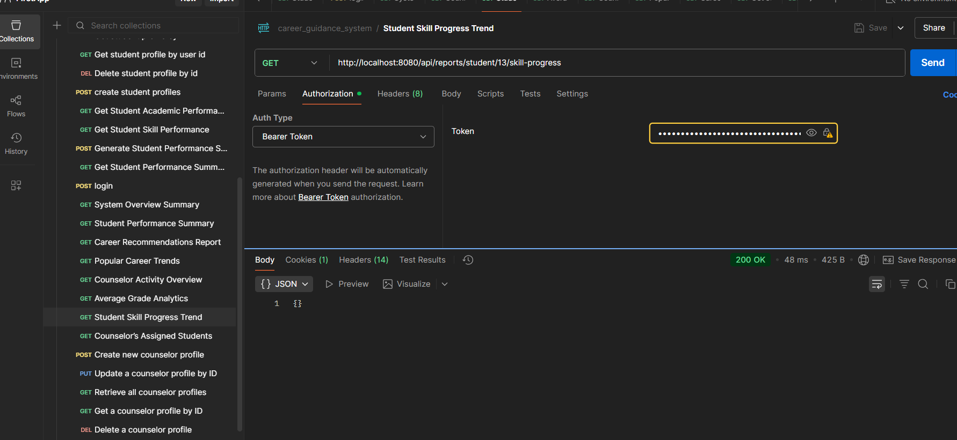
Counselor’s Assigned Students | /api/reports/counselor/  {counselorId}  /students | GET | 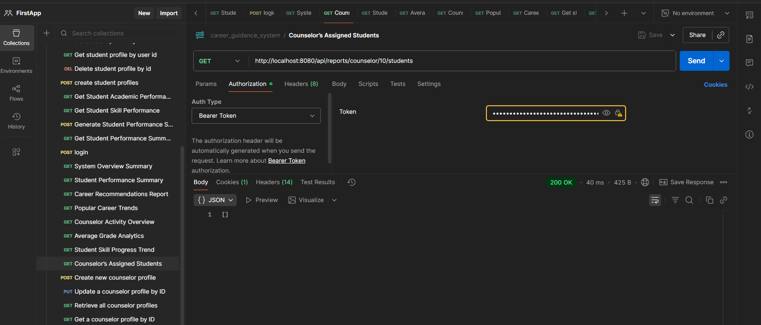

SYSTEM LOGS
description | endpoint | method | Postman screenshot
Retrieve all system logs. | /api/logs/all | GET | 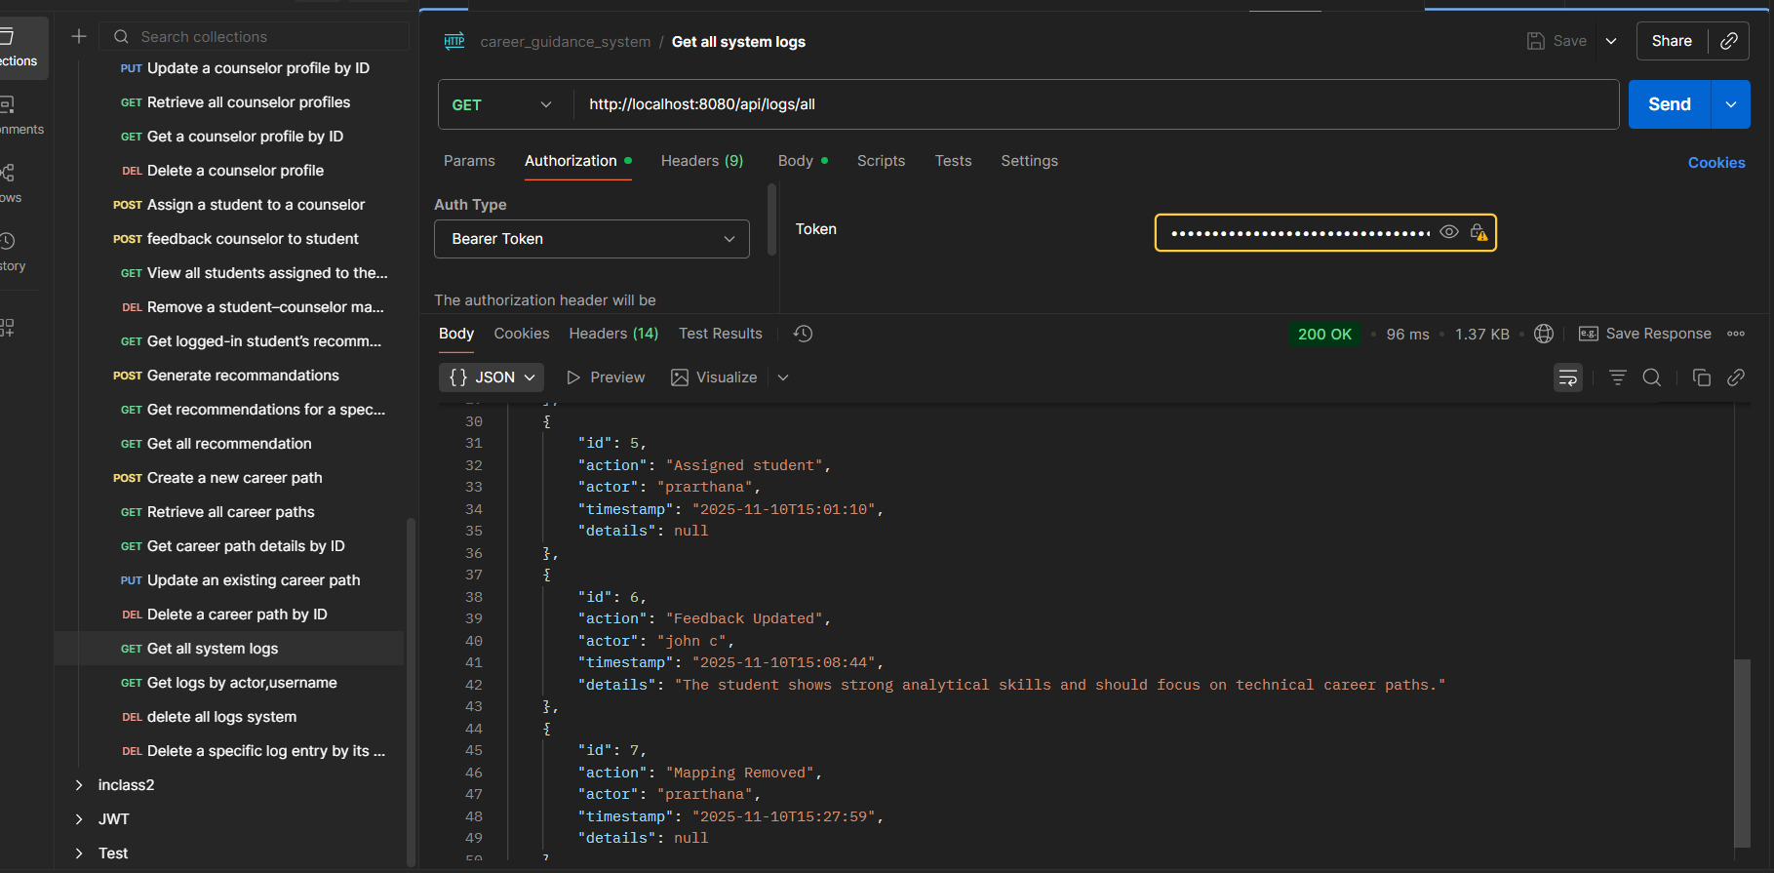
Retrieve logs filtered by actor username. | /api/logs/actor  /{username} | GET | 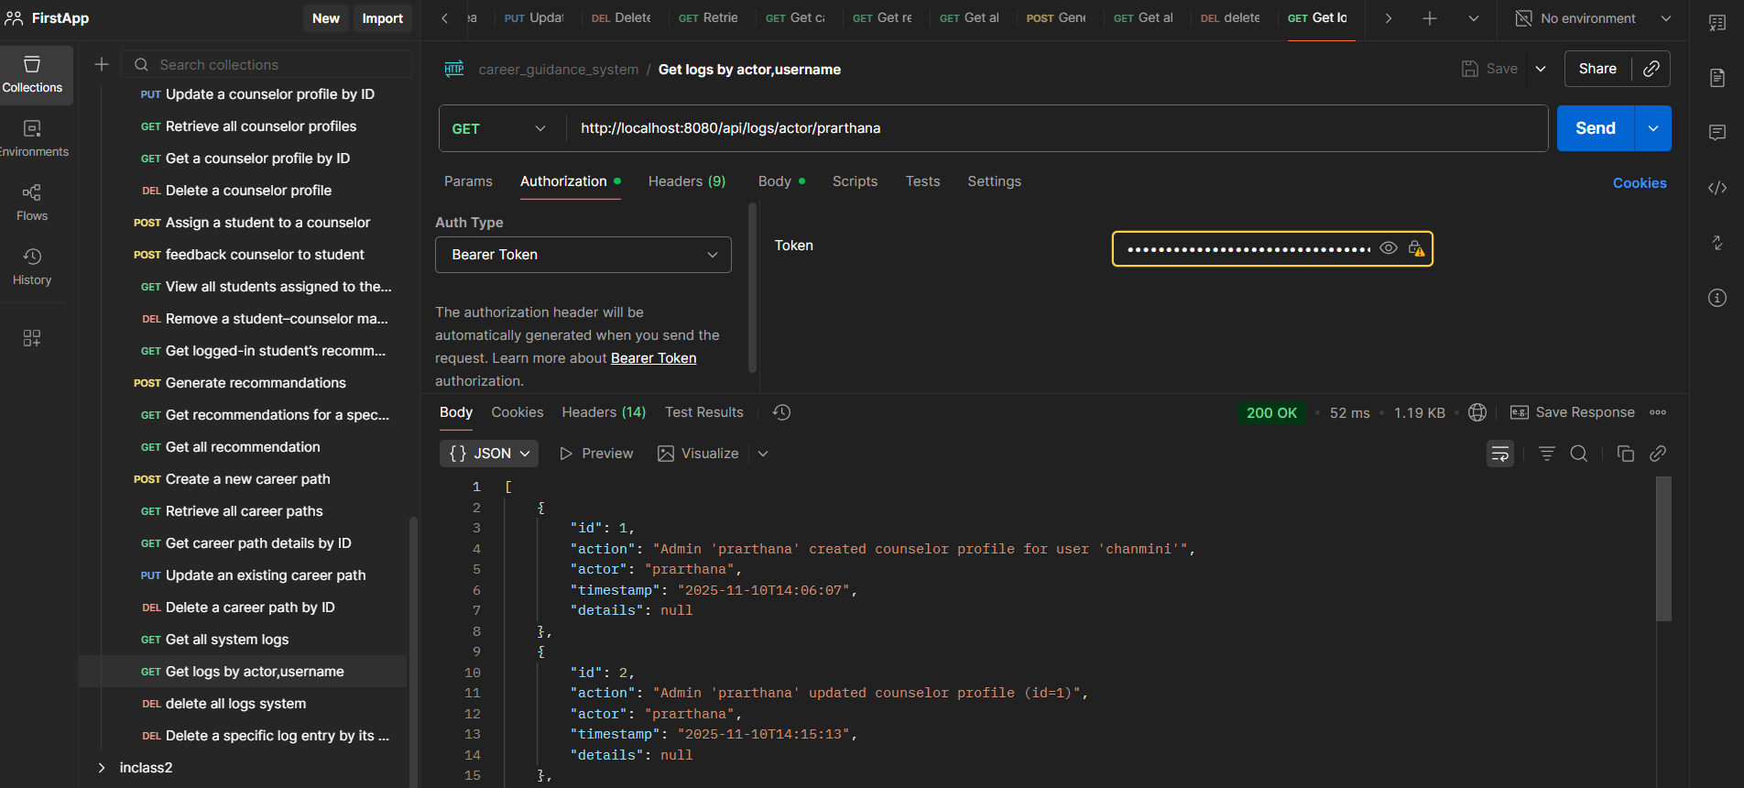
Delete all system logs. | /api/logs/clear | DELETE | 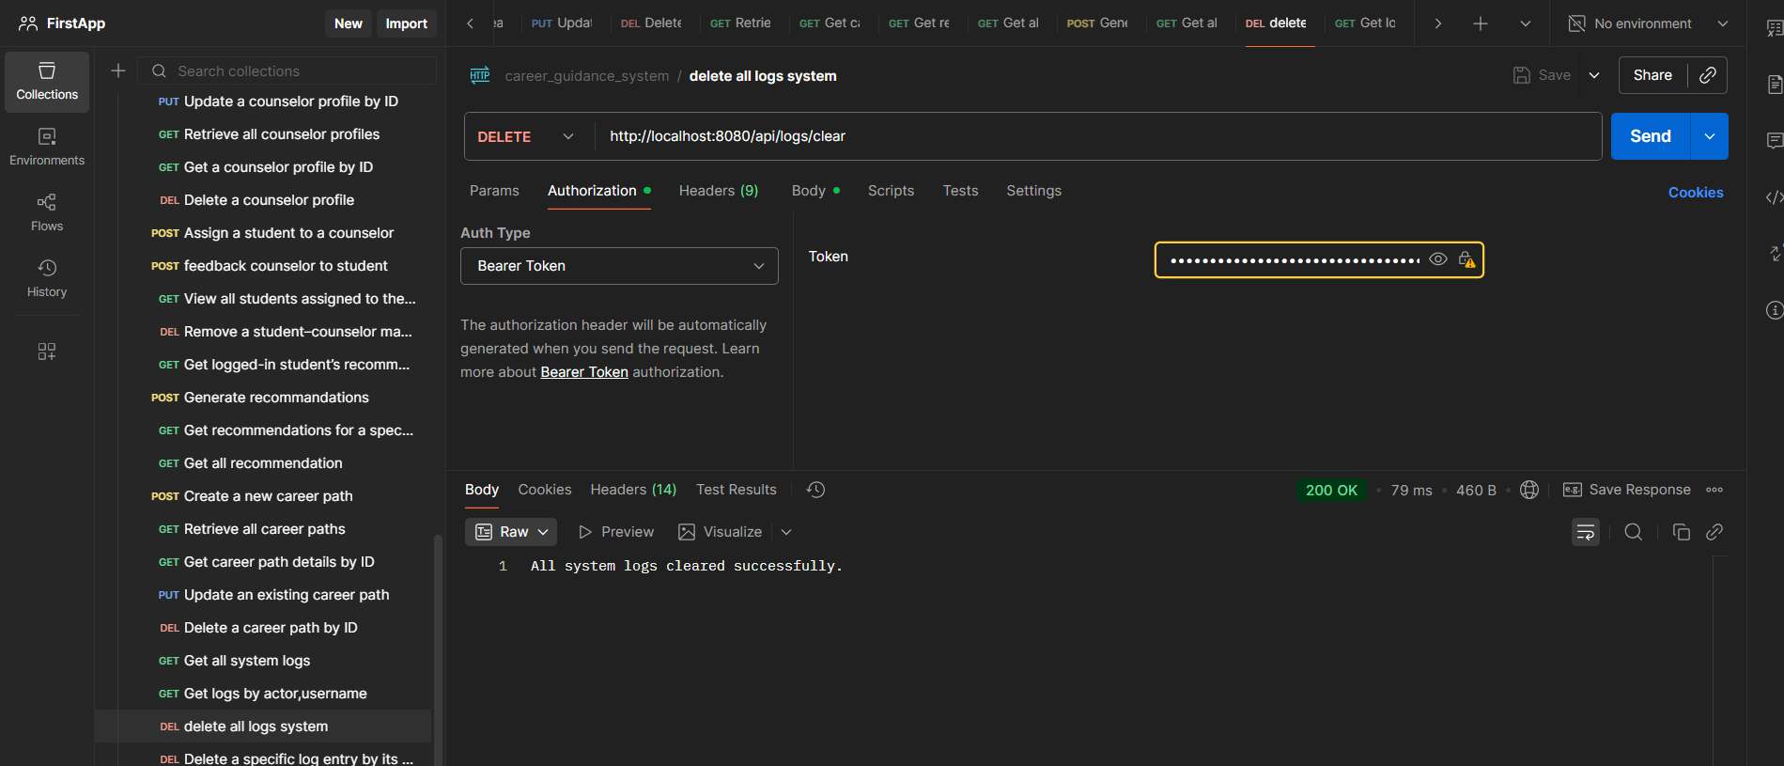
Delete a specific log entry by its ID. | /api/logs/{id} | DELETE | 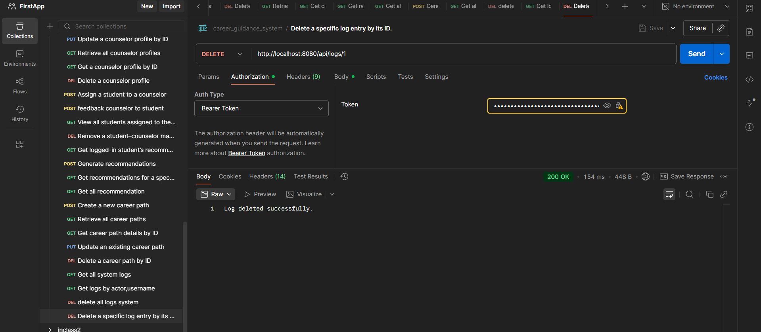

- END TO END SYSTEM WORKFLOW OVERVIEW

System 1: Authentication System - System Flow

1. User Registration
- User fills the sign-up form with username, email, password, and role.
- Frontend sends the request to POST “/api/users/add.”
- Backend checks for duplicate email or username.
- Backend encrypts password using BCrypt.
- User is saved in the users table with the associated role_id.
- Backend returns success or error response.

2. User Login
- User enters email and password.
- Frontend sends POST /api/users/login.
- Backend validates the credentials.
- If valid, backend generates a JWT containing:
  - username
  - role
  - issued and expiration time
- JWT is returned to the frontend.

3. Secured Endpoint Access
- Frontend stores the JWT and sends it in the header:
Authorization: Bearer <token>.
- JwtAuthenticationFilter intercepts the request.
  - extracts username
  - validates token
  - loads the user details
  - sets authentication
- Access is granted only if the role matches endpoint rules.

4. Role-Based Interface Flow
- Students see student dashboard.
- Counselors see counselor dashboard.
- Administrators see admin dashboard.

System 2: Student Profile Management - System Flow

1. Create or Update Student Profile
- Student logs in and receives a JWT.
- Frontend sends profile data using POST /api/student-profiles/add.
- Backend extracts the logged-in user from JWT.
- Access is validated:
  - Student can update only their own profile.
  - Admin can update any profile.
  - Counselor cannot update profiles.
- The profile is saved in student_profile table.

2. View a Student Profile
- Request goes to /api/student-profiles/{id}.
- Backend checks the role from JWT:
  - Student can view only their own profile.
  - Counselor can view assigned students only.
  - Admin can view any profile.
- Backend returns the requested student profile.

3. Delete a Student Profile
- Only administrators can delete.
- Request uses DELETE /api/student-profiles/{id}.

4. Data Flow
Tables involved:
- users
- student_profile
- student_counselor_mapping (used to limit counselor access)

System 3: Student Performance Analysis - System Flow

1. Data Retrieval
Backend loads all:
- Academic records from academic_performance
- Skill assessments from skill_assessment

2. Processing Logic (Triggered by /summary/{studentId})
- Fetch all academic performance data for the student.
- Fetch all skill assessment scores.
- Calculate average academic score.
- Sort skills to identify top three skills.
- Determine overall performance level (High, Medium, Low).
- Create a PerformanceSummary object with the analysis.
- Save the summary in the performance_summary table.

3. Viewing Performance Summary
- Student or authorized user requests:
/api/performance/summary/{studentId}
- Backend checks role:
  - Student: only their own summary
  - Counselor: assigned students only
  - Admin: any student
- System returns latest performance summary.

System 4: Career Recommendation System - System Flow

1. Student Initiates Recommendation
- Student logs in and role is verified by JWT.
- Student triggers career recommendation generation.
- Frontend calls POST /api/recommendations/generate.

2. Backend Recommendation Logic
- Validate that the user role is Student.
- Load student skills from skill_assessment.
- Load all career paths from career_path.
- For each career path:
  - Compare student skills with required skills.
  - Calculate match ratio (matched / total required).
  - Determine match level (High, Medium, Low).
- Save only High and Medium match results into career_recommendation table.

3. Viewing Recommendations
- Student: /api/recommendations/my
- Counselor: /api/recommendations/student/{id}
- Admin: /api/recommendations/all

4. Output Includes
- Career name
- Required skills
- Confidence score
- Match level
- Recommendation date

System 5: Counselor and Admin Management System — System Flow

1. Counselor Profile Creation and Management

Create a Counselor Profile
- Administrator logs in and obtains a valid JWT token.
- Administrator submits counselor details using POST /api/counselors/add.
- Backend verifies that the requester is an Admin.
- Backend checks that the counselor is linked to an existing user account.
- Counselor profile is stored in the counselor_profile table.
- A system log entry is saved.

Update a Counselor Profile
- Administrator sends updated data through PUT /api/counselors/update/{id}.
- Backend verifies that the requester is an Admin.
- Backend loads the existing counselor profile.
- Fields such as name, department, experience, and contact details are updated.
- Changes are saved to counselor_profile.
- A system log entry is recorded.

View Counselor Profiles
- Administrator requests all counselor profiles using GET /api/counselors/all.
- Backend returns all rows from counselor_profile.

View a Specific Counselor
- Request made to GET /api/counselors/{id}.
- Backend allows:
  - Administrator to view any counselor.
  - Counselors to view only their own profile.
- Requested counselor profile is returned.

Delete Counselor Profile
- Administrator sends DELETE /api/counselors/{id}.
- Backend validates the role.
- Profile is deleted from counselor_profile.
- A system log is generated.

2. Student–Counselor Mapping Management

Assign a Student to a Counselor
- Administrator calls POST /api/mappings/assign/{studentId}/{counselorProfileId}.
- Backend checks:
  - Requester is Admin.
  - Student exists.
  - Counselor exists.
  - The student is not already assigned.
- Mapping is saved in student_counselor_mapping.

Counselor Adds or Updates Feedback
- Counselor submits feedback using POST /api/mappings/feedback/{studentId}.
- Backend verifies:
  - User role is Counselor.
  - Student is assigned to this counselor.
- Feedback is saved to student_counselor_mapping.
- The lastUpdated timestamp is refreshed.

Counselor Views Assigned Students
- Counselor requests GET /api/mappings/my-students.
- Backend identifies the counselor from JWT.
- Backend returns all students linked to this counselor.

Administrator Views All Mappings
- Administrator sends GET /api/mappings/all.
- Backend returns all rows in student_counselor_mapping.

Administrator Removes a Mapping
- Administrator sends DELETE /api/mappings/remove/{mappingId}.
- Mapping record is removed.
- A system log entry is created.

3. Data Flow
Tables used:
- counselor_profile
- student_counselor_mapping
- student_profile
- users
- system_log
The system enforces strict role-based access using JWT.

System 6: Reporting and Analytics System — System Flow

1. System Overview Reporting (Admin Dashboard)

System Summary
- Administrator sends GET /api/reports/overview.
- Backend calculates:
  - Number of performance summaries
  - Number of career recommendations
  - Number of system logs
- Summary is returned as a statistical overview.

Counselor Activity Summary
- Administrator calls GET /api/reports/counselor-activity.
- Backend reads system_log and groups entries by actor.
- Returns activity count for each counselor or admin.

Average Grade of All Students
- Administrator requests GET /api/reports/average-grade.
- Backend reads performance_summary.
- Calculates average grade across all students.
- Returns a single numerical result.

2. Student Dashboard Reports

Performance Summary
- Student calls GET /api/reports/student/{studentId}/performance.
- Backend verifies student identity using JWT.
- Backend retrieves the performance summary from performance_summary.
- Summary is returned.

Career Recommendations
- Student calls GET /api/reports/student/{studentId}/recommendations.
- Backend fetches all rows from career_recommendation for the student.
- List of recommendations is returned.

Skill Progress Report
- Student or counselor calls GET /api/reports/student/{studentId}/skill-progress.
- Backend retrieves skill assessments sorted by date.
- Backend groups skills into time-based progress lists.
- Data is returned for chart generation.

3. Counselor Dashboard Reporting

Popular Career Trends
- Counselor or administrator calls GET /api/reports/popular-careers.
- Backend counts how many times each career was recommended.
- Returns a map of career names with their counts.

Assigned Student Summaries
- Counselor or administrator calls GET /api/reports/counselor/{counselorId}/students.
- Backend retrieves students assigned to the counselor.
- For each student:
  - Fetch performance summary
  - Fetch recommendations
- Returns an aggregated view of student progress and readiness.

4. Data Flow
Tables used:
- performance_summary
- skill_assessment
- career_recommendation
- student_profile
- student_counselor_mapping
- system_log

- ER DIAGRAM
